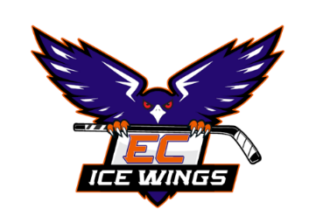
ECYH Multiple Association Player Instructions
Players who intend to dual roster must complete this form. The form is located on the ECYH website.
If you are entering into Dual Roster Agreements between multiple associations, please fill out this form and send it to ECYH President for signature at klm081101@yahoo.com. The President will return the signed form to you or, if it is fully executed, forward it to the Central Section for approval.
Players cannot skate until the Central Section approves the Dual Roster form.
All signing parties acknowledge:
- The Player is committed for the current season and has an obligation to attend all “Current Association” games and practices in the event of any scheduling conflicts.
- All financial obligations must be paid in full to “Current Association”.
- Agreement is not considered a Player Financial Release.
- The signed agreement must be submitted to the Section President for approval.

