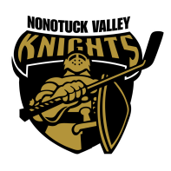
VP/GSL Site
- Change in software from Season Management to Sports Management in Sports Engine for 24-25 season
Coaching Chief
- Proposal to outsource specialized clinics for all age groups in 24-25 season
  - Powerskating clinics, goalie clinics and any other specialty clinics offered
  - Proposal and pricing request from Stick Time Sports
    - Stick Time Sports offers a number of different clinics and will include NVHA coaches on ice
Events
- Banquet scheduled for April 7th at the Log Cabin
Equipment
- Pinneys for evaluations in stock
- Shelving to be built for storage closet at Lossone
  - Motion for association to pay for construction materials- Board voted in favor
Evaluation Committee
- Proposal to utilize outside coaching staff for evaluations for 24-25 season
  - Includes a change in the by-laws to include new player evaluation guidelines (USA Hockey guidelines summarized and adapted by Coaching Chief Pauli)- Attached packet
  - Motion to move forward with evaluation changes-Board voted in favor
League Fees
- Proposal to raise league fees
  - Mites $975.00
  - Squirts/Peewees $1575.00
  - Bantams $1575.00
  - Midgets-No Change
    - Mutli-Child discount reviewed 10% discount for each child registered after the initial child (discount taken from lowest registration fees)
Board Elections
- Vice President- Mark Hibbert
- Secretary- Clay Delano
- Events- Jen Pasquini

Nonotuck Valley Knights Board Meeting
February 07, 2024

