3rd and 4th Grade
Offensive Schemes
At PGBL, we believe in the importance of strong fundamentals while also preparing players for the increased complexity and pace of game as they develop
As players grow through each age level, it’s important to match offensive schemes to their development state.
Younger athletes (grades 3rd and 4th) benefit most from simple, easy to remember actions that emphasis spacing, passing and cutting and movement without the ball.
At the 5th and 6th grade level, their improved ball handling, decision making and understanding of the game flow allows ability to introduce more structured, basic screening concepts.
By the 7th and 8th grade, players are better equipped to run multi-option sets, read defenses, and apply more advanced strategies.

5 Out Pass & Cut
Purpose: Teaches spacing, cutting and movement without ball
Setup: Players start in a 5-out (perimeter)-two wings, two corners, one top
How it works:
- Player at top passes to either wing
- After passing, player cuts straight to basket
- Wing player looks to pass to the cutter for a layup
- If no layup, ball is swung to corner, and repeat
Give and Go
Purpose: Intro to basic two-player actions
Setup: Top and wing
How it works:
- Ball handler passes to wing
- Immediately cuts to the basket after pass
- Wing looks to hit her on the cut
- If no option, wing dribbles up to top and resets
5th and 6th Grade
UCONN
Purpose: Easy play to achieve pick and roll
Setup: 3 out, 2 in formation
How it works:
- Point guard (1) makes pass to either wing.
- (1) will immediately cut through to the opposite corner after making the pass to the wing.
- Post player on the ball-side low block (5) will step out to the corner dragging the post defender out of the key
- (4) will then sprint off the weak-side low block and set a screen on the correct angle for (3)
- (3) attacks the rim looking to score and (4) rolls to the hoop
- (2) slides to the top of the key for safety
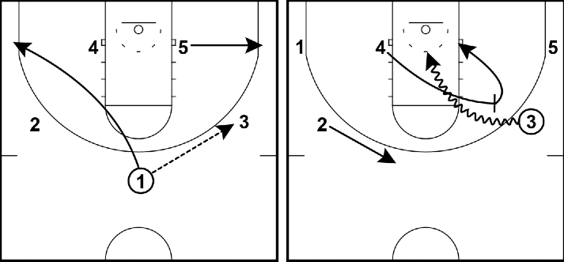

4-Out Pass, Cut, Fill

Purpose: Teach cutting, filling open spots and continuous movement
Setup: 4-out with one player in the paint
How it Works:
- Anytime a player passes, she cuts to the basket
- If player doesn’t get ball, she exits to the opposite corner
- A perimeter player fills the open spot on the pass
- Post player on weak side at all times
- Movement continues until someone gets a layup or open shot

7th and 8th Grade

Isolate

Purpose: Teach how to identify mismatches in the low post
Setup: Players start in a 4-out 1-in formation with the 4 outside players above the free throw line on the wings and in the slots
How it Works:
- The play begins with (1) passing to (3) on ball side wing
- (5) immediately flashes to the basketball to take advantage of their mismatch inside
- When pass in made into low post, the wing players both screen up for the slot players and they both replace each other.
- (5) can back down in the post or face up and attack to the middle or baseline
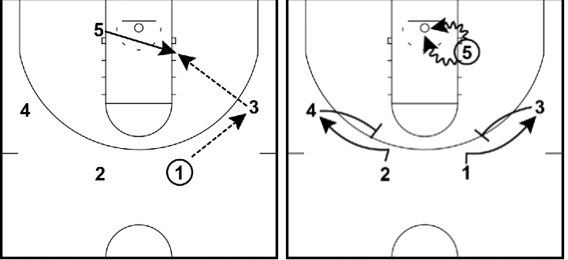

Ghost

Purpose: Involves up screens, post screens and post player (5) hunting for (1) defender to set a strong screen
Setup: Play begins in a 4-out 1-in formation with 4 perimeter players above or in-line with free throw line
How it Works:
- Play starts with the point guard (1) making the pass to (2) on the wing
- As pass is made, (5) sprints up and sets a strong screen on the back of (1) defender as (1) cuts off the screen towards the rim
- If this pass is open, (2) will make the pass inside the key to (1) for the layup
- If layup isn’t available, (1) clears out to the weak-side corner
- (5) will then immediately set an on-ball screen for 2 on the wing
- (2) attacks the rim off (5) screen as (5) rolls to the rim looking to create an opportunity to score
- As (2) is driving to the rim, (3) and (4) slide up and into open passing lanes for the potential open shot and to play safety
