
MINUTES TO BE APPROVED AT THE NEXT BOARD MEETING. THESE MINUTES ARE NOT CURRENTLY POSTED AND SHOULD NOT BE DISTRIBUTED UNTIL APPROVED BY USASSCS BOARD.
Board Meeting Minutes November 11, 2024
Location: Santee City Hall
Attendees Shown with Marked Box
Guests:
President | Jay Strandberg | x | Field Prep | Kevin Hopkins
1st VP/ Field Prep | Erik Ruiz | x | Field Prep | Trevor Henton
2nd VP | Kelli Timanus | x | Field Prep/Uniforms | James Timanus
Treasurer | Tiffany Lynch |  | Field Prep | Shane Hanson
Secretary/Safety Coordinator/Head Scorekeeper | Bryan Scholar | x | Field Prep | Brad Allen | x
Tax Advisor | Lori Britt |  | Field Prep/Equipment | Shane Frary | x
Player Agent | Lance Craw | x | Field Prep
UIC/Parliamentarian | Felicia Leca |  | Head Team Parent Coordinator | Dana Hisaw | x
Field Scheduler/Fall Ball Coordinator | Chris Klima
Webmaster/Social Media/All-Star Coordinator | Alexis Ruiz | x
BOTH Tournament Coordinator/Picnic Coodinator | Kayleigh Ponciano-Ahue | x | Snackbar #1 | Katja Moskowicz | x
Sponsorships | Kylee Scholar | x | Snackbar #2
Awards | Janis Aiello |  | Social Media Coordinator | Sophia Vigil | x

Meeting called to order: 7:05 PM
Meeting Minutes
Katja Moszkowicz motioned to approve minutes from October 2024. Eric Dechant seconded the motion.
Meeting rule – One Topic at a Time
Financial Update (Tiffany L)
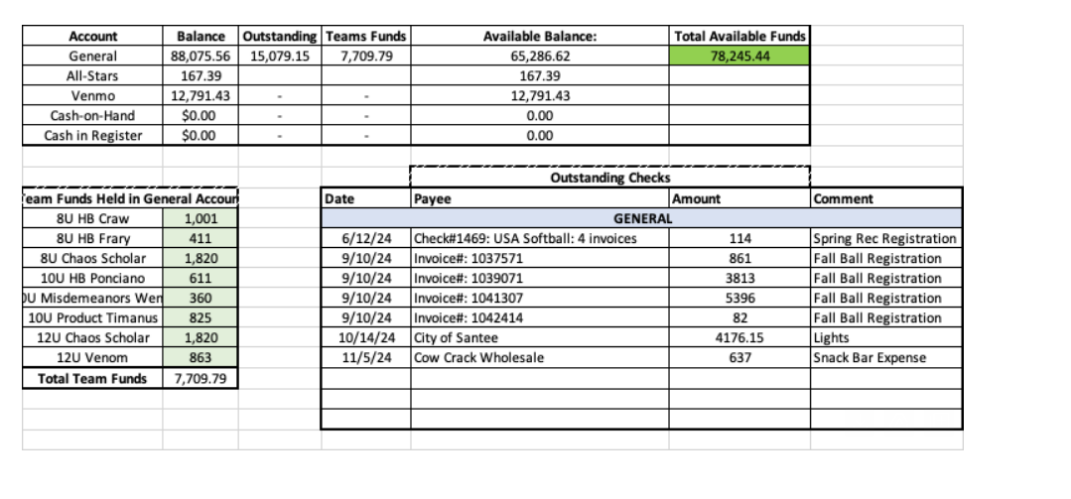
Fall TOC
- Umpires covered for Fall 1904 and Rec TOC
Fields
- Fields 2, 3, & 4 to close on Nov. 21 and will remain closed through Jan. 12
Fall Select Meeting
- Select Manager meeting set for December 3 at the fields under the gazebo
Snack Bar
- Erik Ruiz to work on increasing water temperature

Spring Rec Season
- Warm Up Clinic: January 15 – 17: 6 – 8 pm each night
- Evaluations January 18 – 19
- Manager Meeting: Jan 22
- Draft: January 23
- Opening Day – February 8
- Spring Break: April 5 - 11
Fields
- Jay will order chalk
- Field prep team will add feathers before Halloween Havoc

Meeting Adjourned: 8:16 pm
Next Meeting: December 9

