Tim Brennan – Head Football Coach
Bishop Kelly High School
7009 Franklin Road
Boise, ID 83709-0998

Place
Stamp
Here

Daily Schedule

Check in: Monday at 9:15 a.m.

Monday – Thursday

10:00 Dress

10:15 Stretch/Warm-up

10:30 Individual Skills

11:15 Water Break

11:30 Small Group Skills

12:30 Lunch (bring your own)

Motivational Talks

1:00 Dress

1:15 Stretch

1:30 Small Group Skills

2:00 Team Period

2:50 Speakers

3:00 Camp Ends

Bishop Kelly

2020

Youth Football Camp

26th Annual

Instructional Contact Football

Individual Offense/Defense

For Students in Grades 3 – 8

June 22-25, 2020

(Monday – Thursday)

Camp ends at 12:00 pm. on Thursday

Camp Director
Tim Brennan

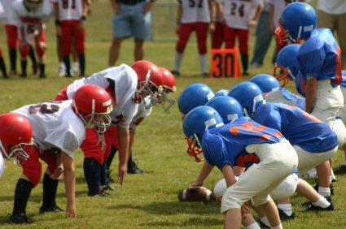

CAMP INFORMATION

The philosophy of the Bishop Kelly Football Camp is to provide a positive introduction into the basic skills of tackle football for students, grades 3 through 8.

Emphasis will be placed on proper blocking and tackling techniques. Every athlete will have the opportunity to learn both offensive and defensive positions.

Athletes will be grouped according to their age, size, and skill levels. All drills will be closely supervised with individual instruction a priority. The four-day camp will be conducted by the Bishop Kelly Football Staff and selected guest coaches from the area’s top programs.

- Athletes will need to bring their own football equipment except helmets.
- We will provide helmets.
- They will also need to BRING THEIR OWN LUNCHES.

TRAINING FACILITIES
The Head Trainer and all training facilities will be made available to all athletes enrolled in the camp for the week.

LOCATION
Bishop Kelly High School
7009 Franklin
Boise, ID 83709
(208) 375-6010-school
(208) 949-3907-cell
tbrennan@bk.org

Send Applications to Bishop Kelly High School by June 19, 2020 or register on line at. https://bishopkelly.sportngin.com/register/form/503674462#_ga=2.248274183.129857724.1581354461-344108411.1548879473
Or: go to BK.org
-click on to Life at BK
-Summer camps

You may register the 1st day of the camp.

FEE $150; $120 for additional family members. If you do not register on line please make checks payable to:
BK FOOTBALL.

Includes:
• Football Fundamentals
• Helmet
• Camp T-Shirt
• Insurance

Registration Form:

NAME _________________________
ADDRESS ______________________
________________________________
PARENTS NAMES ________________________________
PARENTS E-MAIL
________________________________
HOME PHONE __________________
SCHOOL _______________________
AGE__________ GRADE _________
EMERG CONTACT_______________
EMERG PHONE __________________

INSURANCE
The accidental medical insurance provided by the Bishop Kelly Football Camp is an excess policy. The insurance will pay for covered expenses incurred, which are in excess of those payable by other valid and collectible individual or group insurance.

The undersigned has read and understands the terms and conditions of the Accidental Medical Expense Insurance Provided by the Bishop Kelly Football Camp. I hereby authorize the camp staff to act for me in case of emergency and I waive and release the camp from any and all liability for any injuries incurred while at camp.

_____________________________________
SIGNATURE OF PARENT OR GUARDIAN

