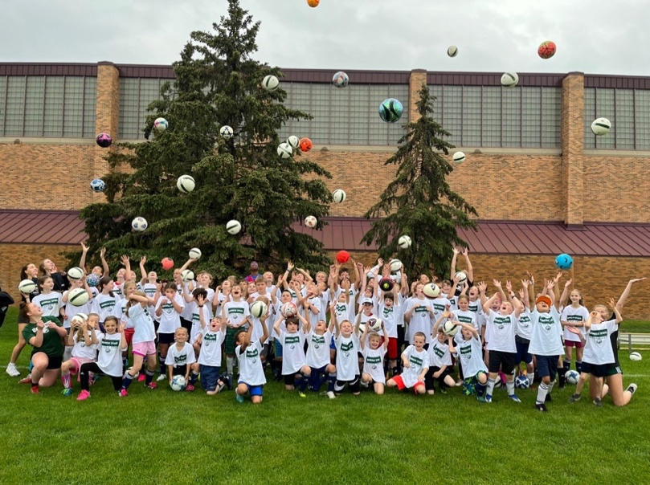
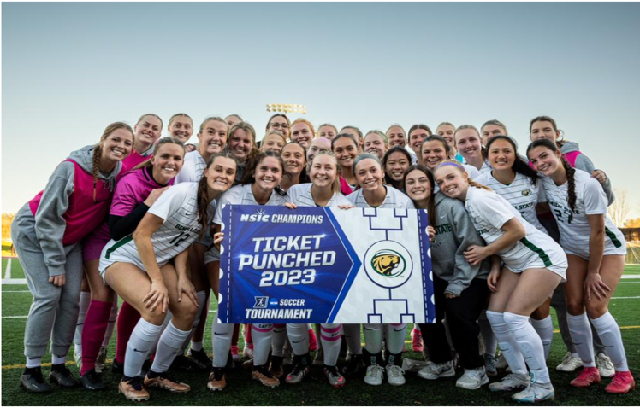
CAMPERS EXPERIENCE:
- Soccer in a fun, safe, social setting…
- Our world-famous World Cup Tournament
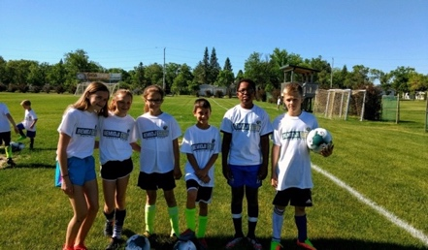
- Coaching from current BSU Soccer Players
Questions Email: beaver.soccer.camps@bemidjistate.edu

For: Boys & Girls
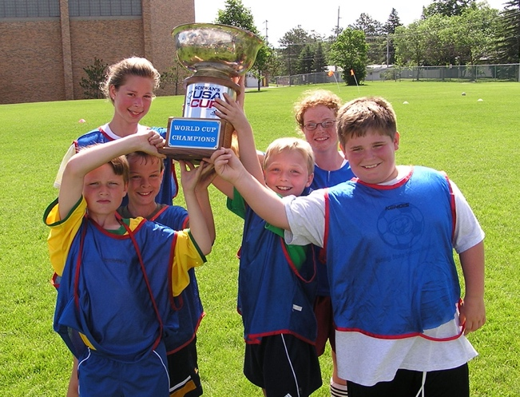
Ages: Entering Grades 1-8
Monday – Thursday: 9:30 AM -
3:30 PM

Cost: Only $105 *Includes Ball & T-shirt

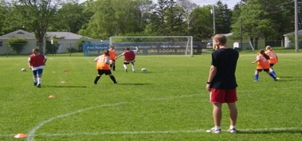
*REGISTER HERE: https://bemidjistatesoccercamps.totalcamps.com/shop/EVENT

