The 2025 Porter Parent Football Association (PPFA) Newsletter – Week2
The LTHS Porter Parent Football Association (PPFA) is a volunteer group dedicated to enhancing the football experience for players. Our goal is to foster a positive, memorable environment for each player, achieved through support for both the players and coaches. The PPFA funds its efforts through various fundraising initiatives, including spirit wear, player sponsorships, and volunteering.
- Twitter @LockportFootba1 - Facebook @ LTHSFootballBoosters  - Lockportfootball.com
Every Week
Varsity Players Pasta Dinner – Every Thursday @ Cooms Corner
Week2 Pasta Dinner: 9/4 @ 4:30pm **Parent Volunteer and/or Dessert Donation**
** Ask-a-Porter ** - 10Q with Michael Pratt
Game Schedule/Results
Varsity: Porters vs Lincoln-Way West: Fri 9/5 @ 6:15pm Game Preview **Senior Night**
Porters over Plainfield North on 8/29 (32-0) Game Recap
Sophomore: Porters vs Lincoln-Way West: Sat 9/6 @ 9:00am Porters over Plainfield North on 8/30 (20-0)
Freshman A: Porters @ Lincoln-Way West: Sat 9/6 @ 9:00am Porters A lose to Plainfield North on 8/30 (0-21)
Freshman B: Porters @ Lincoln-Way West: Sat 9/6 @ 11:15am Porters B lose to Plainfield North on 8/30 (0-42)
News and Notes
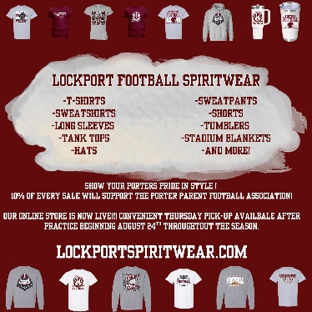
Order your 2025 Lockport Football Spirit wear HERE Homecoming Committee (game 10/3) **Volunteer**

PPFA Board Meeting: 9/16 (Tuesday) @ 7:00pm – LTHS (Porter Room)
Save-the-Date: 10/3-Homecoming 10/31-State Playoffs (first round)
Helpful Links
Spirit Wear Game Digital Tickets IHSA Football Info 8to18

