The 2025 Porter Parent Football Association (PPFA) Newsletter – Postseason
The LTHS Porter Parent Football Association (PPFA) is a volunteer group dedicated to enhancing the football experience for players. Our goal is to foster a positive, memorable environment for each player, achieved through support for both the players and coaches. The PPFA funds its efforts through various fundraising initiatives, including spirit wear, player sponsorships, and volunteering.
- Twitter @LockportFootba1 - Facebook @ LTHSFootballBoosters  - Lockportfootball.com

Game Schedule/Results
Varsity: Porters lost to Oswego on Sat 11/22 (7-10) Game Recap
News and Notes
A huge thank you to all the parents who volunteered at our Pasta/Breakfast meals, concessions, and other fundraisers. Thank you for purchasing Spiritwear or our coupon books (see below). As we look to our final Porters Football Event for 2025, the Varsity Banquet, please signup soonest and we look forward to spending the evening to celebrate the season with our players and coaches. We also bid farewell to Samantha, from the PPFA board, whose years volunteering enriched our program…Thanx Samantha!!
Save-the-Date: 12/8 – Varsity Banquet (5pm) @ Crystal Grand Banquets (RSVP here) **RSVP** **RSVP** **RSVP** **RSVP**
**Lost and Found** Missing a PPFA 2025 Newsletter? Click HERE
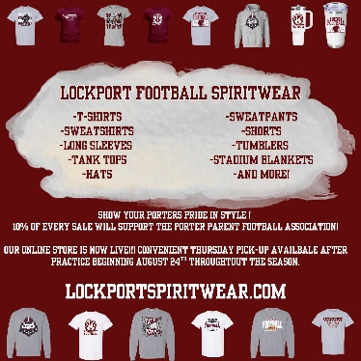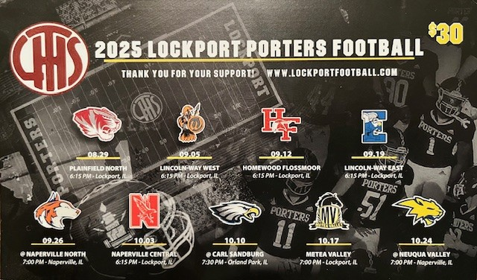
Order your Lockport Football Spirit wear HERE Discounted 2025 Coupon Book - $20? Contact mailto:mkmatthes@yahoo.com
Helpful Links
Spirit Wear Game Digital Tickets IHSA Football Info 8to18

