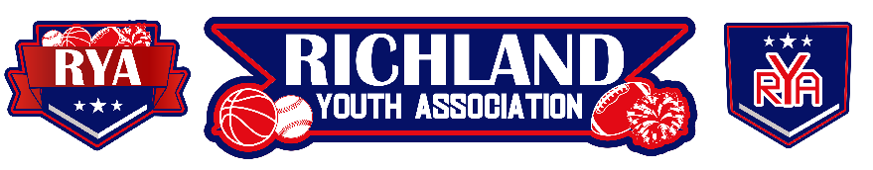
RYA September 2023 BOARD MEETING
Meeting Date: September 6, 2023 – 6:30pm
Board Member Attendees: Mike Cowan, Richard Stutheit, Eric Gomez, Lisa Willis, Erica Stutheit
Absent: Kevin Vorpahl, Tammy Treadwell, Emily Standifer
Non-Board Member Attendees: Mrs. Cates

General Board Items / Old News
- Convicted individual paid $500 check for August.
- Board Elections set for November 15th at 6:30pm.
  - 2 potential volunteers for Rec Baseball Director during upcoming elections.
  - No volunteers for Basketball Director
- Sports Directors need to be monitoring the weather app for excessive WBGT. Cancel/limit practices and games as needed.

Basketball: Vacant
- Still searching for a new Basketball director.
- Erica initially said she could handle the Basketball program until a director is found.
- Lisa and Eric volunteered to take over Basketball program, since Lisa was exploring a Cheer program to go along with it and Eric has been working with her during the Football/Cheer season.

Rec Baseball: Richard Stutheit
- Season is starting soon, practices are underway.
- Jerseys are in from Zexez and have been distributed to their respective coaches.
- No major issues at this time.

Premier/Tournament Baseball: Kevin Vorpahl
- The first tournament has good turnout for 12u and 14u divisions. Still two additional tournaments planned for Fall.

Football: Eric Gomez
- Football exploring fundraising opportunity, presented by Mrs. Cates at start of meeting.
- All seven teams are set to make the playoffs. RYA does not keep gate money for playoffs, but NWTX handles all referee costs.

Cheer: Lisa Willis
- Working on Homecoming items.
- Exploring possibly having a Cheer program to coincide with RYA Basketball season.
- Lisa is trying to get a Cheer board set up through NWTX Board.

Communications: Erica Stutheit
- Assisting with Basketball registration building. Also soliciting volunteers for the open Basketball Director board position via social media and email.

Special Events: Emily Standifer
- Working with Richard on Fall Baseball opening day, bounce houses.

RYA Bank Accounts total of $40,448.19 and $936.90

Meeting adjourned at 8:52 pm

