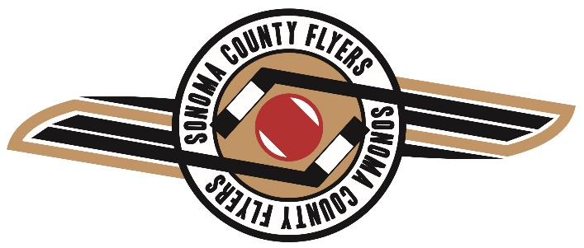

With all the challenges that Covid-19 has brought to us this year, we are happy to announce High School hockey team tryouts. While we cannot guarantee when and if there will be a regular season, we are happy to put together a team with the expectation that at minimum, we will be able to participate in some out of state tournaments.
Registration for virtual tryouts begins Friday 11/20. We will be providing a registration link on the SRJHC website.
We intend to provide a comprehensive experience for the players though for the time being.
You can also expect from us:
- Innovative coaching- Coach Jesse is spearheading new digital tools that many of you have been exposed to including digital practice plans prepared and sent to players for review prior to practice. We have also purchased a TV with mirroring technology to provide additional training support.
- Increased # of practices, we are planning to schedule at least three practices per week
- A true team approach- the more effort that you put into this, the more you will benefit
- We are looking to incorporate a new fresh look. We looking at a new and updated uniform package which will enable the team to have a consistent and professional look.
- When gyms can open, we have an amazing personal trainer Kendra Mancini to provide a world-class dryland workout.
- Compete in the Sharks Ice High School Hockey League pending that games can occur
- Chalk Talk sessions
- We will be looking at multiple tournament opportunities
- Season length is anticipated December through May unless coronavirus restrictions make that impossible
We are looking forward to offering a unique and exciting experience for all players. Upon selection, we will ask for $250 deposit. With the uncertainty that Covid brings, we will re-evaluate the season costs based on the County and State regulations.
We anticipate having a very well-rounded, competitive team and we are looking forward to a great year no matter what Coronavirus brings.

