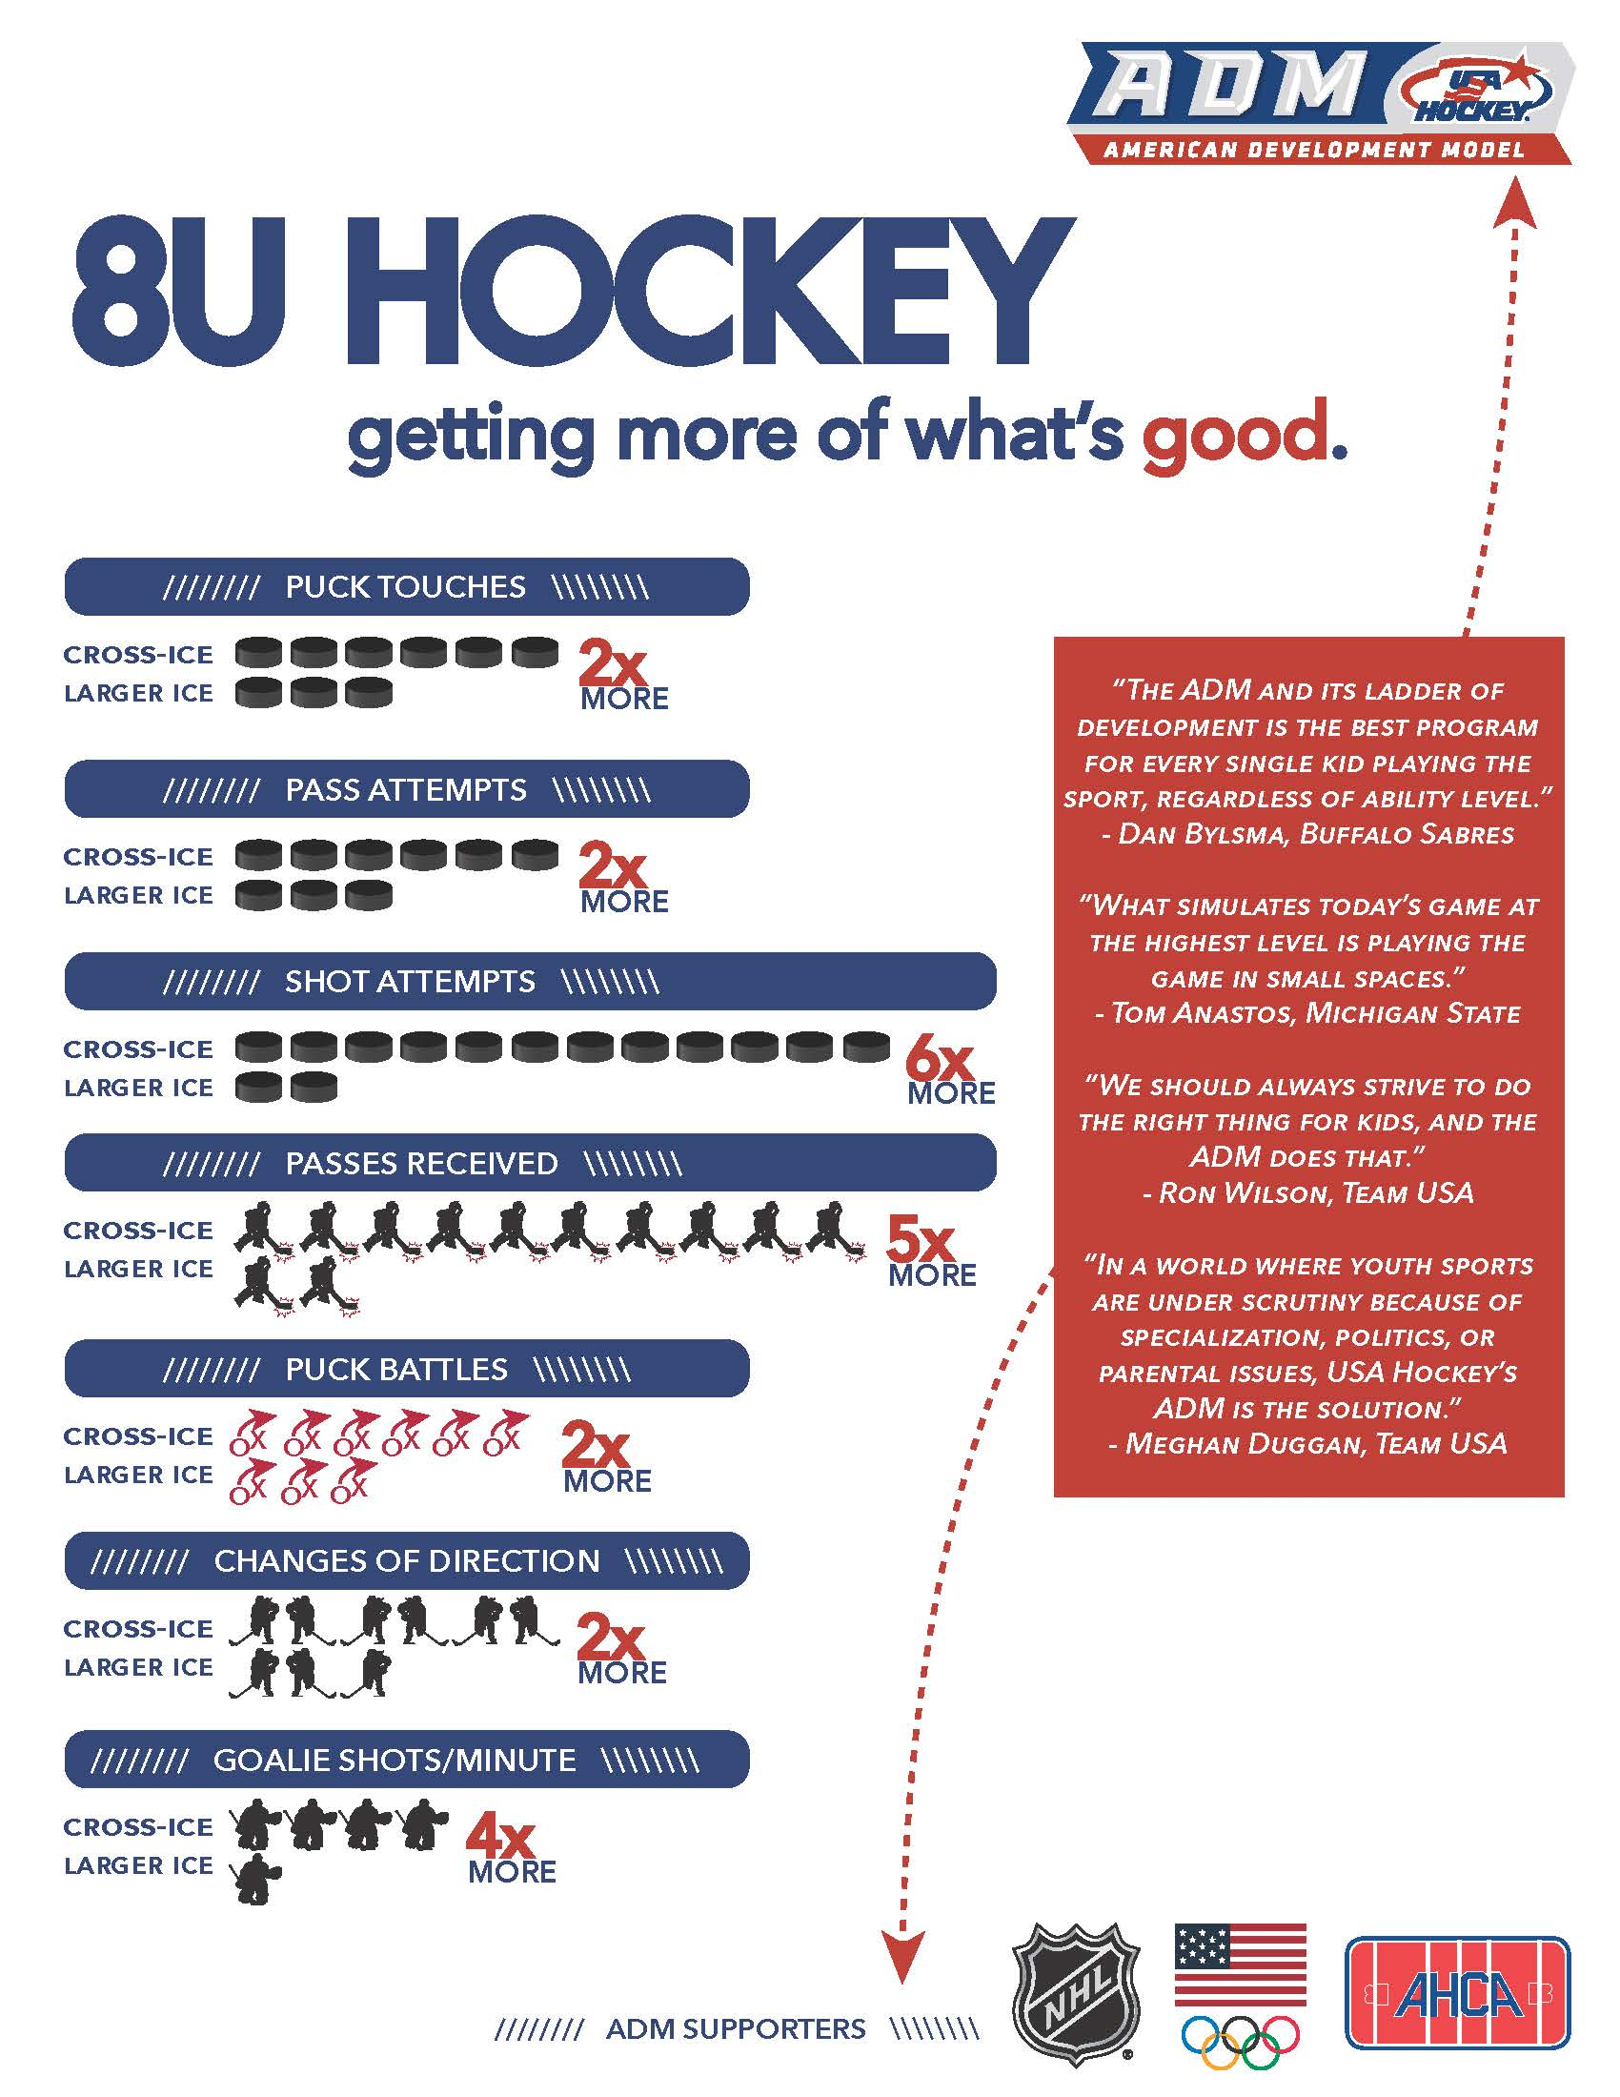
8U
8 & Under

Practice Fundamental Movement Skills (FMS) like
running, swimming or jumping. Also
introduce the ABC’s of athleticism:

ABC’s - Agility, Balance & Coordination
and Speed.

Focus on flexibility during this stage.

This is the first window for speed training
with an emphasis on agility, quickness and
change of direction. Less than 5 seconds
in duration.

Once a week, prior to or after practice,
spend 30 minutes off-ice working on the
Fundamental Movement Skills and the ABC’s.
This can be done through games and challenging
activities. Keep it fun!

Play multiple sports and engage in activities like
soccer, running, gymnastics, swimming, skiing
or other activities 75% of the time and play hockey
the other 25%.

Group players into top 1/3, middle 1/3,
beginner 1/3.

30 – 60 players each practice session

- 2-3 ice touches per week
- 50 min ice sessions
- 5 month’s = 20 weeks per season maximum
- 50 to 60 ice touches per season

Min 16 cross ice/half-ice games & 34 practices

Max 20 cross ice/half-ice games & 40 practices

9 to 13 players/team; no fulltime goalies

