PROMOTIONAL TEMPLATES
February 2024

HOW TO USE THIS DOCUMENT
The following document will provide you with all of the promotional templates that you might need for making the HundredX program a success for your organization. Please note that these are general templates and you should customize them to your specific organization by highlighting your incentive program and changing the wording to match your program’s information. Please copy and paste content from this document when using it.

SIGN UP LINKS
Anyone 18 years or older) can sign up for the program by doing one of the following sign-up methods:

- Online through this link: https://hundredx.com/teamsnap
- Text “TEAM” to 90412 on their phones

EMAIL INTRO - PLAIN TEXT
Email Invitation Copy - Please Edit for Your Organization and Copy and Paste

Hello Parents and Friends,
We have an exciting announcement! We're running a 30-day campaign with HundredX Causes to bring you a way to create funding for [organization name] without spending a cent.
Here's how it works: Now through March 13th, each time you share a quality brand opinion with HundredX, $1 goes towards team and club support! You can personally create up to $75 of value (by giving 75 pieces of feedback).*
Sign up here: https://hundredx.com/teamsnap
P.S. When you join the campaign on behalf of our club, your personal information is not sold or shared to any third parties. During the campaign, you will receive reminders from HundredX to submit feedback for the club. You may opt out at any time.

SOCIAL MEDIA PROMOTIONS
NOTE: you can add an explainer video to these posts but you will need to download the video from this link and upload it to your social media post.
-----
HundredX Causes is a totally free way to create funding to help us [use of proceeds]. YOU can help – use HundredX Causes to share your opinions on companies & brands through March 13th. Each time you do, you create $ of impact for [your organization]! It’s free, fast, and secure! Check it out here: https://hundredx.com/teamsnap

SOCIAL MEDIA IMAGES
Editable Graphics (If you want to use images of your organization’s players in your promotion)


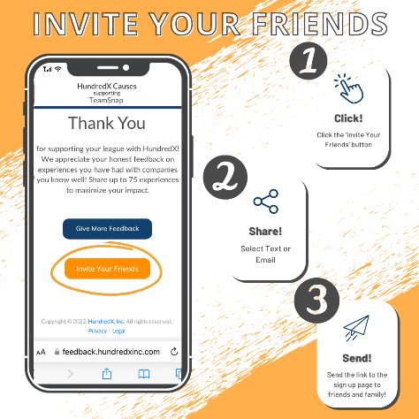

FREQUENTLY ASKED QUESTIONS AND ANSWERS

What am I supposed to do after I sign up?
- Immediately after signing up, you will be able to click on your personalized feedback link and start raising money for your cause. You will also receive an email and/or text message containing your personalized feedback link . You can return to your personalized feedback link email/text message at any time to give feedback.
- From your personalized feedback link, you will be brought to the HundredX main Feedback page. From here, you can choose ANY brand from more than 1700 options in HundredX’s brand universe and share about a brand experience you have had in the last six months. Search for brands in the search bar or find them by category.
- After you select a brand, provide your opinion using our simple and fun, one-minute emoji-based system. Please only submit honest feedback on actual experiences you have had – this allows HundredX to create the most trusted brand insights.
- Repeat this process on a variety of companies to create more impact for your cause! Throughout the program, you will receive email and/or text reminders to continue providing feedback until you have reached the maximum feedback count for your program (which is indicated at the top of your feedback page).

I signed up but I can’t find my welcome email and/or text. What should I do?
Sometimes, HundredX Causes emails are filtered into promotional, spam, junk or other folders, so we would recommend checking these for your welcome email. All HundredX Causes text message reminders will come from 90412. The welcome email will come from support-causes@hundredxinc.com, and any reminder emails will come from causes@hundredxinc.com. We recommend adding both addresses to your contacts so you don’t miss an email from us.

How do I get back to the page where I can give feedback?
There is no login or password requirement for your HundredX personalized feedback page - you can access the feedback menu at any time through your personalized link in any previously sent email or text. Because of this, once you have signed up, you do not need to return to the program signup form.

I have shared my opinions. How do I know how many pieces of feedback I have given?
When you click on the link to give feedback in a reminder text or email, you will be brought to the main feedback page where you can either search for a brand or find it in one of the categories. The feedback count at the top of the page will contain your current number of pieces of feedback submitted. You can also find your feedback count in any reminder messages (emails or texts) that you receive from HundredX Causes.

How will I know if I have reached the maximum?
You will receive an email and/or text to notify you when you have reached your maximum feedback limit. You can also check your feedback count at the top of the main feedback page. Once you have reached your maximum feedback count, you will no longer receive email and/or text message reminders from HundredX Causes.

Can I invite friends and family to HundredX Causes? How do I do it? Yes! We encourage you to invite your network to provide feedback to support your cause! You can send the sign-up link or text code (text TEAM to 90412 or click https://hundredx.com/teamsnap) to your friends and family at any time throughout the program! Please DO NOT forward your personal reminder emails or texts from HundredX, as those contain your personalized feedback link.

Email to Individuals Who Haven’t Signed Up Yet
Hello Parents and Friends of [organization name],

As you may have seen, we've partnered with a platform called Express Feedback for Good™ to bring our community a way to create funding for [organization name] without spending a cent.

So far, we’ve created [current $ generated], just from [organization name] supporters giving feedback! We need YOUR help as we come into this final week. We only have until March 13th to get closer to our goal of creating [$ goal] to help us [use of proceeds/how your organization will use the funds].

Every minute you can spare will make a difference for [organization name] players. You can personally create $75 in about an hour (by giving 75 pieces of feedback) - we need YOU on the team!

Please sign up HERE to support your player and [organization name/use of proceeds] and pass along the opportunity to family and friends (have them text “Team” to 90412). Thank you in advance for helping us support our players!

P.S. When you join Express Feedback for Good, your personal information is not sold or shared to any third parties. During the campaign, you will receive reminders from EFG to submit feedback for the club. You may opt out at any time.

