Outfielders Backing Up

Left Fielder
The left fielder needs to back up second base on throws from the right fielder. She also should back up the shortstop and 3rd baseman when the catcher throws to 3rd base on a steal attempt. Furthermore, she should look to back up the center fielder on balls hit to center field.

Center Fielder
The center fielder needs to back up fellow outfielders when the ball is hit to their respective fields. She is also another back up for plays made at 2nd base.

Right Fielder
The right fielder needs to back up first base on ground ball plays in the infield, pick off attempts to first base, and bunt plays. She should back up the center fielder on balls hit to the center field, and she should back up second base on balls hit to left field when the left fielder throws it to second.

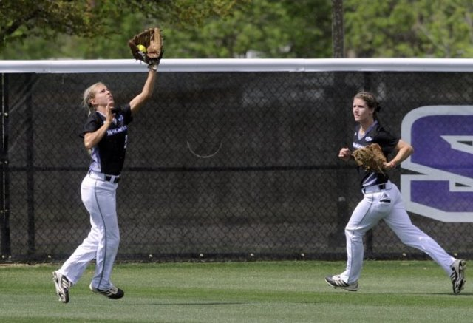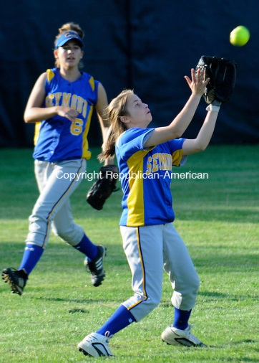

Outfielders should be moving on every play. The have a responsibility no matter the situation!

