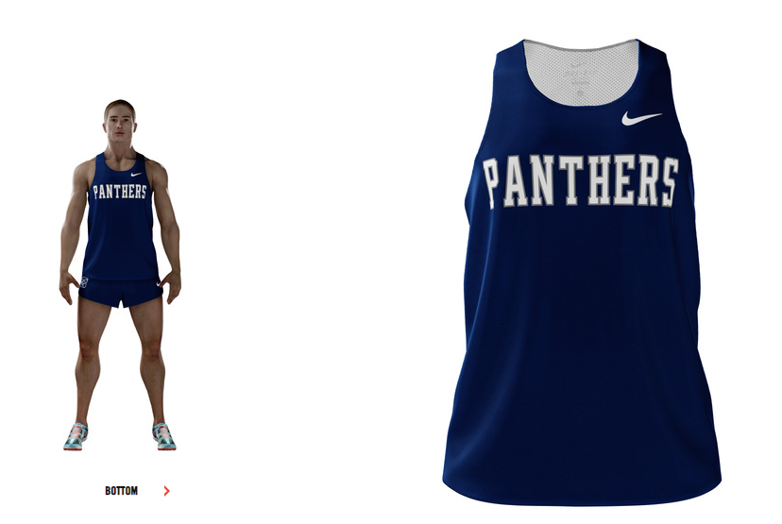
The Rochester Century Boys Cross Country Team is looking to purchase new uniforms for their program and are selling water softener pellets from our local Hy-Vee. If you purchase the pellets, we will hand deliver the pellets and carry the pellets to your softener if you so desire.
Please consider helping out this wonderful cause to support our Local Cross-Country Program
If you have any questions, please contact our coach: Paul Callahan (507)884-1446
We have two pellet purchase options: The Hy-Vee Brand Solar Pellets (Blue Bag) for $8.00 and the Hy Vee Pellets (Yellow Bag) for $9.00
(If individuals ask the difference: Solar salt (blue bag) is naturally evaporated salt and is courser. Pellets are more refined and dissolve more quickly and are created with a binding agent)
Note: If customer is not at home then either drop off under front porch out of rain or ask customer where you should drop off and make a note in the comments section of the form.
Please make all checks payable to Century High School

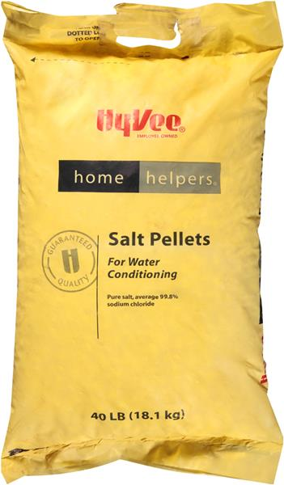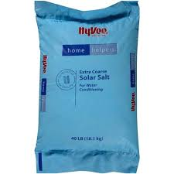
Century Boys Cross Country Uniform Fundraiser

