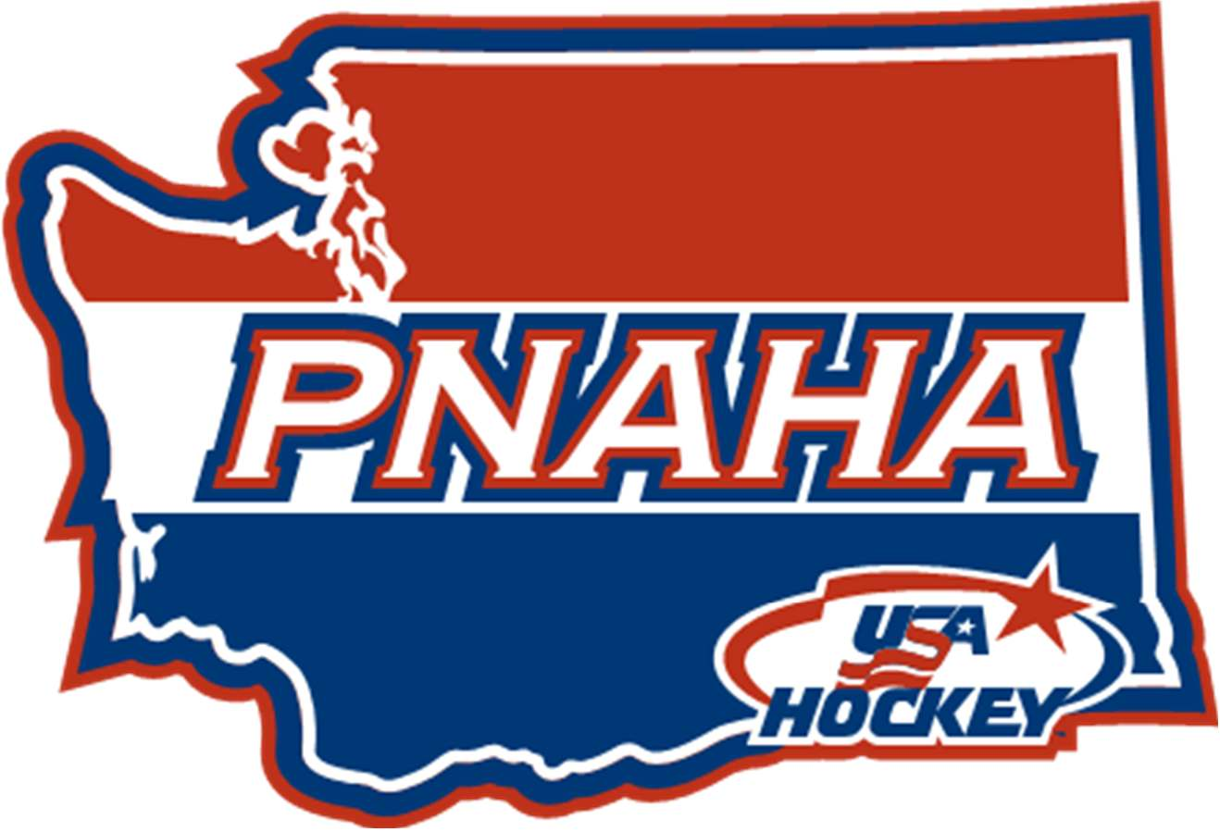
PNAHA EXECUTIVE COMMITTEE MEETING
THURSDAY/FRIDAY, AUGUST 1-2, 2024

Attendees: Jody Carpenter, Tom Ogee, Nicole Adams and Debbie Didzerekis

- State of PNAHA – The Committee did a round table discussion on where PNAHA is on the aspects of a board and on hockey in the state. There are aspects we are doing well at and areas of improvement that we need to focus on going forward.

Items of improvement:
- Communication among associations
- Hockey instruction within the state
- Growth and Development between associations
- Player development path for both recreational players and advanced players
- Tier I player identification process to allow for competition at a national level
- Tier II player identification process and growth at home
- Special Committee for Parent Development in Hockey

- Direction of PNAHA – Where do we want to be?

PNAHA Logo rebranding (recognizable)
PNAHA Leadership Relevant to Associations (resource and available)
Teams Competitive at National Levels
Network of productive committees/volunteers (who are active)
Service Level Agreements to PNAHA required requests and directives
Collaborations between associations
Player first mentality within the state
Developing good hockey parents
3. Mission/Vision Review

PNAHA Tagline
“Every player, Every Opportunity”

PNAHA Mission
“Our mission is to promote the growth and development of hockey in the PNW by providing every player with the opportunity to excel, fostering a love for the game, and encouraging sportsmanship, teamwork, and community engagement.”

PNAHA Vision
“Our vision is to be the leading force in cultivating a vibrant hockey community, where every player, coach, and fan is inspired to reach their full potential and contribute to the sport's enduring legacy.”

4. Compare current to where we want to be and set goals to bridge gap.

- More PNAHA Representatives at USA Hockey Meetings
- Development Camp, we want 2 outside people evaluating (USHL, NAHL or College personnel) at each level.
- PNAHA Team Roadshow, visit each association to discuss collaborations.
- PNAHA Attendance at events

5. Old Business:
Inland Empire Status, failed to provide Member Team applications by deadline of July 31, 2024 after multiple emails and attempts to help the group gain PNAHA Member team status, the group will not be a member of PNAHA. A letter informing them of this status will be sent.

6. New Business:

7. Next Executive Committee Meeting, September 13, 2024, prior to the PNAHA Meeting September 14, 2024 at Jak’s Grill (Issaquah, WA).

Calendar for 2024-2025
September 14, 2024 PNAHA (Snoqualmie Inn – Snoqualmie, WA)
October 12, 2024 Pacific District Meeting (Las Vegas)
October 20 or 21, 2024 PNAHA/USA Hockey Review
December 20-22, 2024 PNAHA Girls Development Camp
January 4, 2025 PNAHA Winter Meeting (Bremerton, WA)
January 16-19, 2025 USA Hockey Winter Meeting (Nashville)
January 31- Feb 2, 2025 PNAHA Tier I Tournament
February 2, 2025 Pacific District Meeting (Irvine)
February 27, 2025 PNAHA Tier II Tournament
March 7-10, 2025 PNAHA Festivals (10U/12U)
March 14-16, 2025 PNAHA B Tournament
March 22-23, 2025 PNAHA Youth Development Camp 15,16,17 (Tacoma)
March 28-29, 2025 PNAHA Youth Development Camp 13,14 (Tacoma)
June (1st weekend), 2025 USA Hockey Summer Meeting (Colorado)
June 9-14, 2025, WRHPC (Colorado Springs)
June 21, 2025 PNAHA Summer Meeting (Spokane Host)
September 13, 2025 PNAHA Fall Meeting (Vancouver Host)

