USA Gymnastics Idaho
Rules and Policies
Updated August 30, 2025
State Administrative Committee 2025–2026
Idaho State Chairperson:
Barbara DePasquale
idaho2usag@gmail.com
(208)-699-2620

North Rep

Lisa Adlard
lisa@cddagym.com

Mark Kindlespire
mlkindlespire@gmail.com

South Rep

Brandon Paine
brandonpaine@broncoelite.com

Jina Whipple
jina.whipple@mountainwestgymnastics.com

East Rep

Cayla Beutler
Cb8773@gmail.com

Erin Jacobsen
Erinjacobsen9@gmail.com

Xcel Rep

Lynne Kindlespire
lkindlespire@frontier.net

Judges Rep

Marian Dewane
mldewane@gmail.com
All correspondence must be sent to the address above—not to the gym.
USAG Idaho Competition Calendar
- Season Duration: August 1 – July 31
- Calendar Updates: Competition dates for the upcoming season will be posted after May 1
- Note: Placement on the calendar does not guarantee priority or judge assignments
- State Meet Hosts: Announced online after the bid process is complete
Sanction Guidelines
- All national sanction guidelines must be followed, along with USA Gymnastics Idaho Rules and Policies
Judging Requirements:
- DEV 4-10/XG-XSa: Two-judge panel per event for all levels
- DEV 1-3/XB-XS: One judge permitted
- Exceptions require approval from the SACC and NAWGJ Chair and USAG RTCC
Requesting Judges
- Submit requests via gymjas.com; instructions are available on the state website
- Meet Directors may request specific judges or exclude certain ones
- Out-of-state judges may be secured independently by meet director
- Fee: $5.00 per judge is due with your request to ID NAWGJ
- Judges may not solicit meets (per USA Gymnastics R&P)
Idaho Reporting Requirements
To qualify to a state meet or for mobility, results must be reported within 48 hours to:
- MyUSAGYM App
- Meet Scores Online
Required within 48 hours:
- Emailed copy of the completed sanction form with all signatures to State Chairperson.
Head tax payment:
- $2 per athlete for local/intrasquad meets
- $5 per athlete for state meets
- Payable to USAG Idaho (do not write the SACC’s name on the check)
- Send to: Barbara DePasquale 6360 N Sunshine St Coeur D Alene ID, 83815
Failure to submit payment will result in disqualification of scores and loss of meet privileges
Additional Requirements:
- Retain meet results for verification
- Meet Referees must report violations to both USA Gymnastics and the SACC
Mobility Requirements - Refer to the National Rules and Policies: Dev page 64
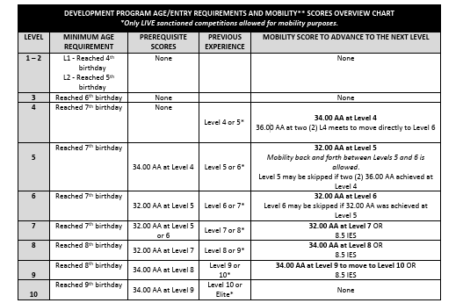

Xcel Page 60
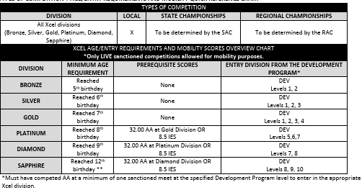
Key Notes:
- Entry level: DP = Level 4; Xcel = Gold
- Mobility scores must be submitted when transitioning from Xcel to DP
- All intersquad scores used for mobility must be reported
- Proof of mobility scores is the coach’s responsibility
USAG Idaho State Meets-Idaho SAC oversees all state meets
State Championships:
- Season (Xcel & Levels 1–10): Dates set by national calendar, with an option of 2 weekends to host.
- Adjustments may be made based on participation numbers and regional championships dates.
Qualifying Scores to State Meet:
DEV 3-10: 32 AA
IES: 8.00 on the event
DEV 1-2: Must compete in 2 sanctioned events during the current season
XCEL B-Sa: 32 AA

DEV Regional qualification is determined by the Regional Committee

Levels 7-10: 34.00 AA or 9.0 as an Event Specialist at State Meet
Levels 8-10: Athletes who do not achieve an AA score may still advance to Regionals on any event where they score a 9.0 or above

Qualification to Xcel regionals:

Gold: % of a % for a total from the State meet

Platinum: 35.00 AA at State meet

Diamond and Sapphire: 34.00 AA at State meet

IES (individual event specialist) - Any Xcel Diamond/Sapphire athletes not declared specialists and achieving a score of 8.5 on any event at their respective state meet may compete at the regional meet on those events.

High school seniors who compete in the state meet can automatically attend the regional meet if they do not get the qualification score needed.

Declaration date

February 14 or, if February 14th falls on a weekend, to be the following Monday for Dev and Xcel.

The level a gymnast enters in the first meet following the declaration date determines the program and level at which they must compete for the remainder of the season.

State Meet Entry Fees and Deadlines:

Entry fee maximum is set in the rules and policies. To go above this fee requires approval by Idaho SAC. Added to the base entry fee include $5 for a regional fee and $5 for a state fee to the total entry fee.
DEVO 1-10
XCEL B-Sa
Age Divisions and Awards
- USAG Idaho has determined that there should be no more than 15 gymnasts per age group. Create age groups based on birthdays.
- Age groups set after entries are received
- Awards distributed to at least 50 percent of participants
- 1st-6th medals minimum given for events and AA. All athletes must receive an acknowledgment medal (uni or qualifier medal) in AA.
- State team scores: Top 3 scores per event count, regardless of AA
- All other awards follow USA Gymnastics R&P
- Medals and Banners are ordered through A-1 awards only.
All State Awards
Levels 6 and 7 = 37.50AA
Level 8 = 37AA
Level 9/10 = 36.00AA
Xcel Platinum/Diamond/Sapphire = 37.5 AA

Clear Diamond Paperweight 3.15" Diameter 80mm. Order through IncredibleGifts.com in California (order a minimum of 15 days in advance) 1-800-982-5992.
USAG Idaho is responsible for the expense and will place the order.
State Meet Host Responsibilities
- Responsibilities are outlined in the State Meet Bid Form,
- This form is considered part of the official USAG Idaho Handbook
Judges Selection – State Meets
Judges are selected by the Idaho SAC. Panels must include 2 judges, with a separate Meet Referee
Selection Criteria:
- Up-to-date memberships and certifications
- Experience and meet history
- Professional development (clinics, camps, volunteering)
- Availability for all sessions
- Active judging at appropriate levels
- Ratings, affiliations, and geographic location
- Professionalism throughout the season
No single factor determines assignments. The SAC evaluates the full portfolio
Judges Selection – Regional Meets
Eligibility Criteria:
- All state-level criteria apply
- Performance history at state and regional meets
- Full availability (no partial attendance)
- No overlap with college assignments
- Experience and feedback from peers
- Frequency of judging requested levels
Questions about assignments must be directed to the State Chairperson only
Meet Dress Code and Conduct
All participants must follow the USA Gymnastics Code of Ethical Conduct
Coach Dress Code (State Meets and Above):
- Athletic shoes with rubber soles
- Athletic or docker-style pants (no jeans)
- Tailored or gym-logo shirts (no spaghetti straps, crop tops, or torn clothing)
- No hats or visors
Conduct Expectations:
- Be professional and sportsmanlike
- No cell phone use on the field of play
- Record only your own athletes
- Attend all coaches’ meetings
- Respect all participants
- Coach only your own athletes unless asked
- Do not approach judges directly
- Be fully certified and prepared—no exceptions
Resources
- State Rules: www.idahogymnastics.org
- Regional Rules: www.usagymnasticsregion2.com
- National Rules: rulespolicies.pdf

