SLPYHA Board Meeting Agenda
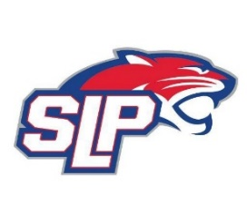
Date: 8/7/22
Roadside
7:00pm

Attendees: Scott Lichter, Mike Mliner, John Pitzl, Kevin Mitties, Jon Tranby, Mike Fitzpatrick, Pat Cleary, Nick Peterson
Guests:

- President Report: Scott Lichter
- Call to order: 7:02pm
- Approve agenda
- Approve minutes from 7/19/2022, motion: Lichter move: Mliner
- Latest D10 updates
- Waiver Sign-off
- Play-up Policy – no changes
- Golf Tournament – Jess Scott
- Secretary resigned – replacement needed
- Vice President Report: John Pitzl
  - 2022-2023 Coaching Application
- Treasurer Report/Gambling Report: Mike Mliner
  - 2022-2023 budget to review at next meeting
  - Team Genuis tryout software – same as last 4 years
  - Board approves the August gambling expenses
- Secretary Report:
- Traveling Director Report: Adam Kiedrowski
  - Tryout volunteers – clock, bench, check-in, locker room monitor
  - Tryout/pre-skate schedules
  - Tryout judges
- Girls Traveling Director Report: Kevin Mitties
  - Registration – CSLP
- Mite Director Report: Mike Fitzpatrick/Pat Cleary
  - Mite jersey order
- Player Development Report: Jon Tranby
- New/ongoing Business:
- Motion to dismiss: 9:07pm, motion: Pitzl move: Fitzpatrick

