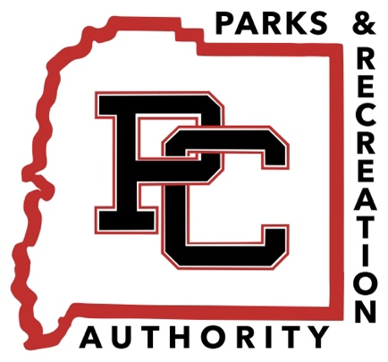

Pike County Parks & Recreation Authority’s Policy on
Political Advertisements and Campaigning at PCPRA Parks & Community Center

To ensure a fair, respectful, and enjoyable environment for all event participants and attendees, the following guidelines apply to political advertisements and campaign activities.

- Signage at Designated Areas Only: Political advertisements may only be displayed through purchased signs that can be hung or placed on designated fields or areas specified by PCPRA.

- No Political Rallies: Political rallies, speeches, or public gatherings intended to promote any political campaign material during games, events, or on event premises is not allowed.
- No Flyers or Printed Materials: Distribution of political flyers, pamphlets, or any other printed campaign material during games, events, or on event premises is not allowed.

- No Political Floats or Campaigning in Parades: Floats, banners, or any form of political campaigning are not permitted in parades associated with the event. This includes team float decorations.

This policy is designed to maintain a neutral and distraction-free environment, prioritizing the enjoyment and comfort of all participants and attendees. Violation of these rules may result in the removal of advertisements or exclusion from the event.

