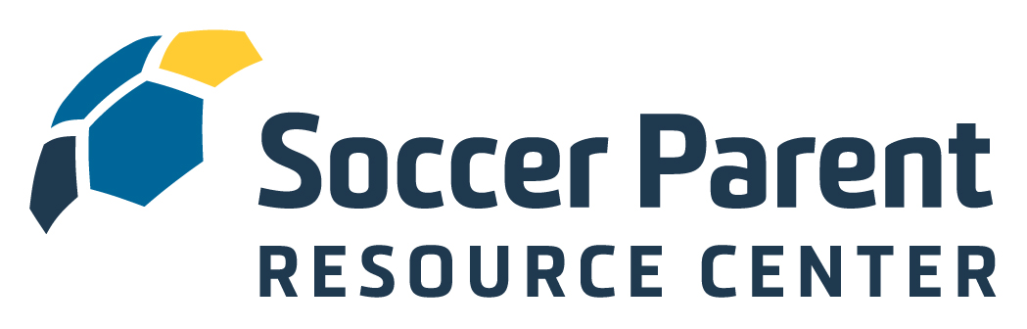
Dear Coach,

I am thrilled your club, Dakota Alliance Soccer Club, believes in the importance of engaging and educating youth soccer parents and has therefore secured a club-wide membership to the SoccerParentResourceCenter.com. You, as well as all the parents of your players, now have access to the interviews, articles, webinars and other educational and community building opportunities at the SoccerParentResourceCenter.com.

Be sure to have your parents register - and also register yourself so you can take advantage of the Coach Education opportunities in the Coaches Area.

Please encourage your families to visit the site and create a free account so they can access all the quality information designed to make your coaching experience, their parenting experience, and – most importantly – the players’ experience on the field the most enjoyable possible.

To activate the membership simply copy this link to your browser:
REGISTRATION LINK HERE

At the Soccer Parenting Association:

- We believe youth soccer parents will be difference makers when it comes to improving the game.
- We believe when parents seek information about how to best support their player, great things will happen.
- We believe a collaborative environment between coach, parent, club, and player is in the best interest of player development.
- We believe a strong and supportive community of level-headed and like-minded parents and coaches will inspire players.

I look forward to connecting with you in the Soccer Parenting Community Forum. If you have any questions, suggestions, or ideas for articles, please don’t hesitate in reaching out.

Let’s Keep Going,

-skye

Skye Eddy
Skye@SoccerParenting.com

