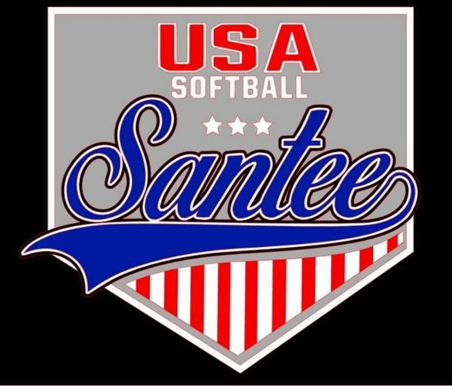
MINUTES TO BE APPROVED AT THE NEXT BOARD MEETING. THESE MINUTES ARE NOT CURRENTLY POSTED AND SHOULD NOT BE DISTRIBUTED UNTIL APPROVED BY USASSCS BOARD.
Board Meeting Minutes January 9, 2024
Location: Santee City Hall
Attendees Shown with Marked Box
President | Jay Strandberg | x | Field Prep | Kevin Hopkins | x
1st VP/ Field Prep | Erik Ruiz | x | Field Prep | Trevor Henton | x
2nd VP | Kelli Timanus | x | Field Prep | James Timanus | x
Treasurer | Tiffany Lynch | x | Field Prep | Nate Anderson
Secretary/Safety Coordinator/Head Scorekeeper | Bryan Scholar | x | Field Prep | Brad Allen | x
Tax Advisor | Lori Britt |  | Field Prep/Equipment | Shane Frary | x
Player Agent | Lance Craw | x
UIC/Parliamentarian | Felicia Leca |  | Head Team Parent Coordinator | Dana Hisaw | x
Field Scheduler/Fall Ball Coordinator | Chris Klima | x | Uniform Coordinator | Jamie DeChant | x
Webmaster/Social Media/All-Star Coordinator | Alexis Ruiz |  | Picnic Coordinator/Pictures | Kat Vecchione | x
BOTH Tournament Coordinator | Kayleigh Ponciano-Ahue | x | Snackbar #1 | Amy Ramirez | x
Sponsorships | Kylee Scholar |  | Snackbar #2
Awards | Janis Aiello | x | Social Media Coordinator | Sophia Vigil | x

Guests: N/A
Meeting called to order: 7:06PM
Meeting Minutes
Tiffany Lynch motioned to approve minutes from 12/11/23. Shane Frary seconded the motion.
Meeting rule – One Topic at a Time
Financial Update (Tiffany L)
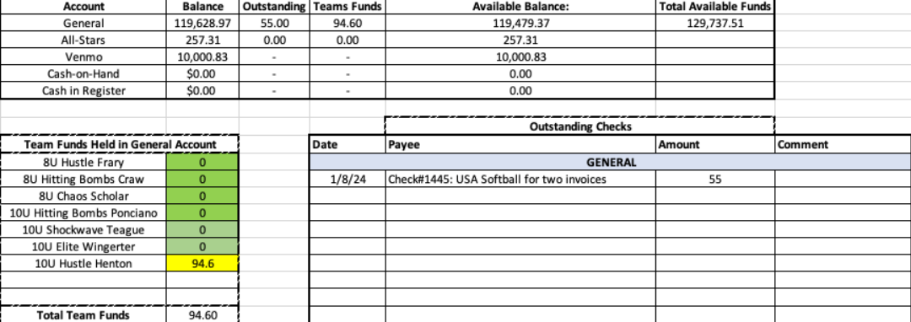

Snack Bar
- Will be open for spring evaluations on 1/13 & 1/14
Spring Select:
Team Rosters Attached – No changes to team rosters for duration of Select Season
  - 3, 8U Teams
    - Lance Craw 13 players
    - Bryan Scholar – 11 players
    - Shane Frary - 13 players
  - 3, 10U Teams
    - Josh Teague – 10 players
    - Bryan Scholar – 10 players
    - Bronson Ponciano Ahue - 11 players
  - 1, 12U Team
    - James Timanus - 12 players
  - 1, 14U Team
    - Chris Klima - 12 players

Spring Rec Managers:
8U Managers
- Lance Craw
- Bryan Scholar
- James Timanus
- Brad Allen
- Matt Johnson
- Jessica Dorman
- Shane Frary
- Rob Hughes
- Kayla Kelly
- Mike Butcher

10U Managers
- Bronson Ponciano-Ahue
- Bryan Scholar
- Josh Teague
- Jason Wingerter
- CJ Nearing
- Matt Elinoff
- Scott Hisaw

12U Managers
- James Timanus
- Paul Arreola
- Joe Thorne
- Dustin Hopkins

14U Managers
- Chris Klima

Spring Rec Schedule:
Warm up Player Clinic:
- Wednesday 1/10: 6:00 – 8:00 pm
  - 8U and 14U on field 1
  - 10U and 12U on field 5
Evals- 1/13 & 1/14
Manager Meeting – 1/17
Draft – 1/18 at City Hall – Room TBD

New Rule for Spring 2024 – 10U division will allow pitchers 7 innings per week

Practices Begin – 1/22
Opening Day – 2/10
Team Parent Meeting 1/30
Scorekeeping Meeting 2/6

Fields/Equipment
- Fields getting cleaned up 1/10 before warm-up clinic
Meeting Adjourned: 8:48 pm
Next Meeting: February 12

