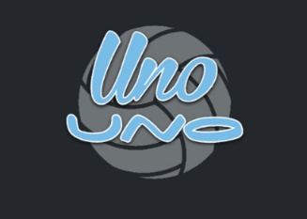
I-80 Invite
Saturday, May 17

4 team pools will play 3 matches, winner of pool gets Adidas gear.
5 team pools will play on two courts, winner of 5 team pools gets Adidas gear.
3 team pools, winner of each pool will crossover and play winner of 2nd pool, that will be the winner of the 2-3 team pools. 2nd places will play 2nds and 3rds will play 3rds.

Schedule is posted on AES here: Home - AES Event Results

$10 entry per spectator, 12 years old and under free. Seniors-$5, cash and card taken at the door and for concessions at UNO.
$10 entry per spectator, 12 years old and under free. Seniors-$5, cash and card taken at the door and cash for concessions at Nowell Recreation Center.

-doors open 1 hr prior to first match start time.
-all teams at UNO Training Center- full concessions available, NO OUTSIDE FOOD (Jimmy Johns, Chipotle, coolers) allowed, please go out to your car to eat those items. Bleacher seating. Outdoor chairs are allowed.
-all teams at Nowell Rec Center-light concessions available. Outside food is allowed. Bleacher seating. Outdoor chairs are allowed.

UNO Training Center(4 courts)—570 Joyce Rd, Joliet-No parking near hydrants or cones near truck loading doors. Parking on north and south side of building allowed. Overflow can park at Cornerstone Services as well.
Nowell Recreation Center(2 courts)—199 Mills Rd, Joliet, IL, parking in lot and on Mills Rd. allowed. If parking on Mills Rd., pull in perpendicular to Mills, do not parallel park on Mills.
Athletic Trainer available at UNO Training Center and Nowell Recreation Center.

