Instructions on how to access the Activities forms and future Registrations.
https://ahconnect.anoka.k12.mn.us/portal/p/applications
Log in to AH Connect, and then select “My Student Information”
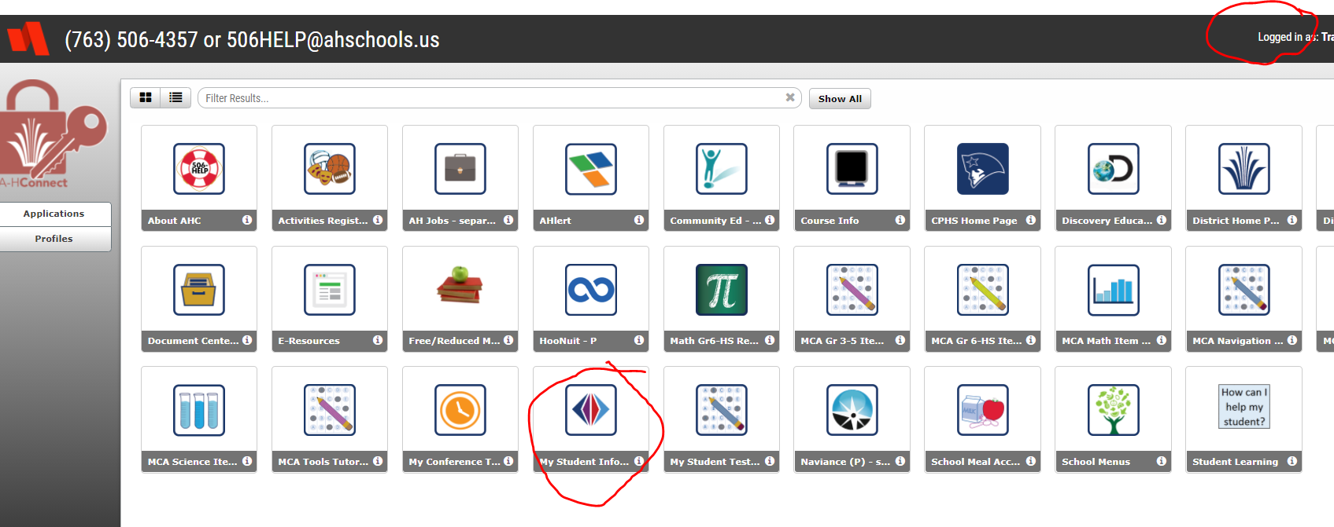
Select “I am a Parent” then it asks you to log in again.
Once in your child’s page, Select Fee from left menu bar
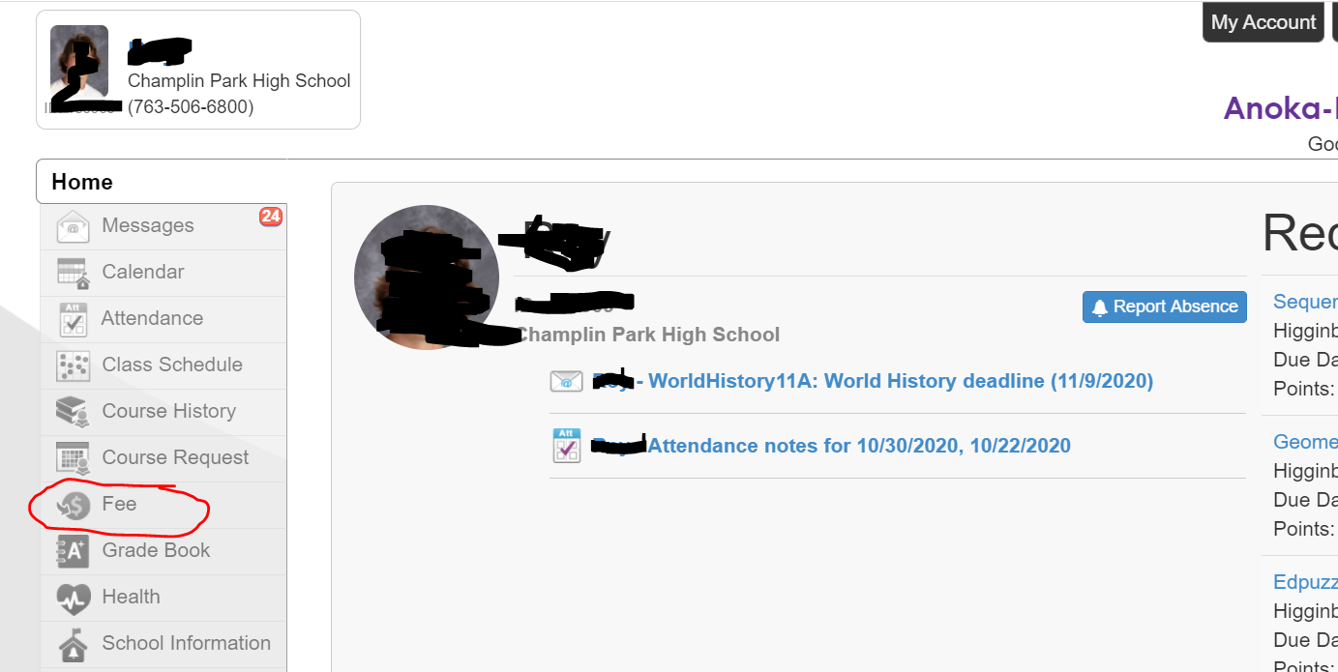
Select “Pay Fees”
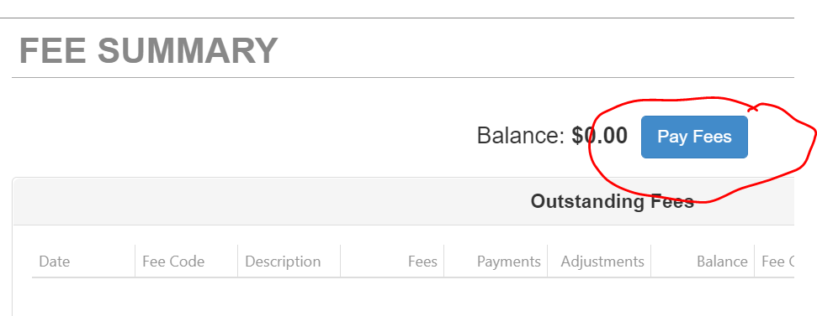

You will see the MSHSL Forms, Select “View Items”
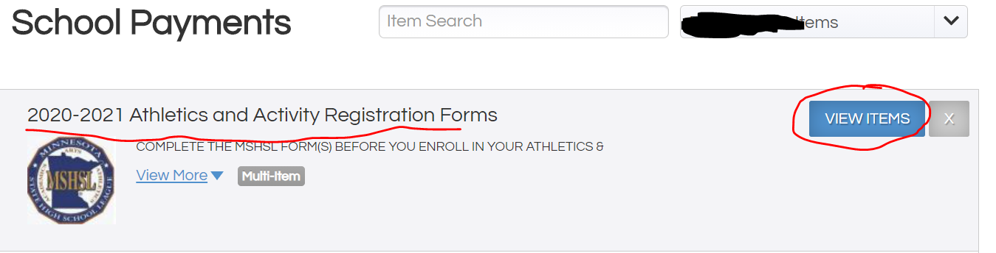
Add each to cart, one at a time, and complete the check boxes as appropriate.
Then check out with a zero balance.
To register for the sport:
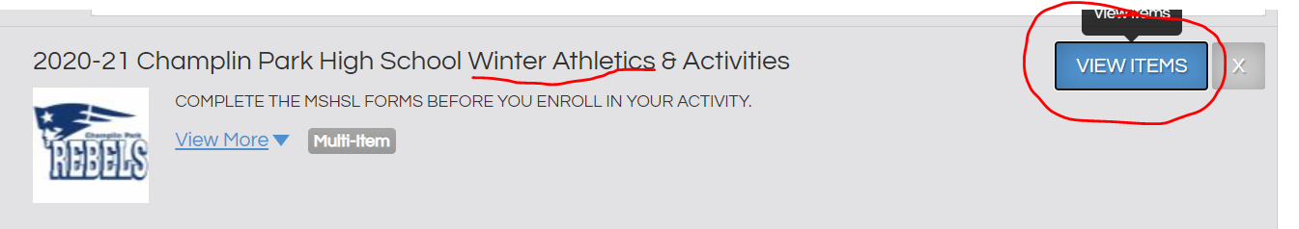
Scroll down
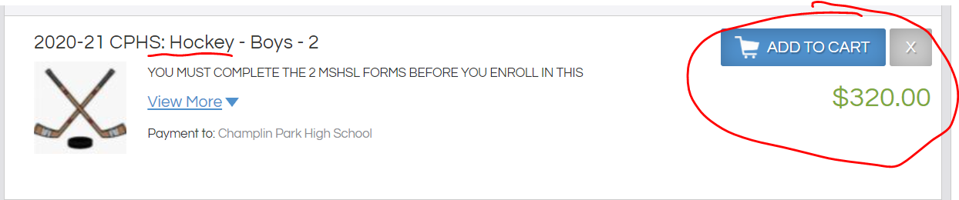
If no activities appear in your feed, it may be that a current physical is not on file. For further assistance/answers, please contact Marcy in the activities office at marcy.burnevik@ahschools.us or call 763-506-6902
Then checkout.

