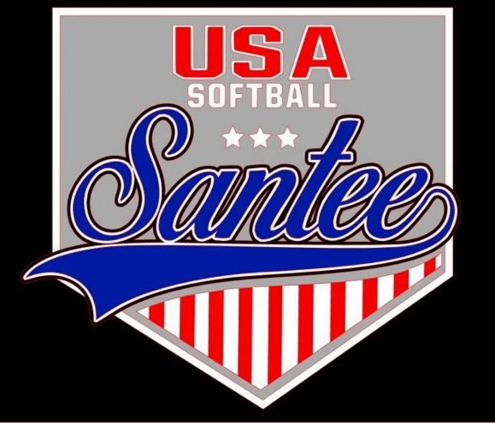
MINUTES TO BE APPROVED AT THE NEXT BOARD MEETING. THESE MINUTES ARE NOT CURRENTLY POSTED AND SHOULD NOT BE DISTRIBUTED UNTIL APPROVED BY USASSCS BOARD.
Board Meeting Minutes March 11, 2024
Location: Santee City Hall
Attendees Shown with Marked Box
President | Jay Strandberg | x | Field Prep | Kevin Hopkins
1st VP/ Field Prep | Erik Ruiz |  | Field Prep | Trevor Henton
2nd VP | Kelli Timanus | x | Field Prep | James Timanus | x
Treasurer | Tiffany Lynch | x | Field Prep | Nate Anderson
Secretary/Safety Coordinator/Head Scorekeeper | Bryan Scholar | x | Field Prep | Brad Allen | x
Tax Advisor | Lori Britt |  | Field Prep/Equipment | Shane Frary | x
Player Agent | Lance Craw | x
UIC/Parliamentarian | Felicia Leca | x | Head Team Parent Coordinator | Dana Hisaw | x
Field Scheduler/Fall Ball Coordinator | Chris Klima | x | Uniform Coordinator | Erik Ruiz
Webmaster/Social Media/All-Star Coordinator | Alexis Ruiz | x | Picnic Coordinator/Pictures | Kat Vecchione | x
BOTH Tournament Coordinator | Kayleigh Ponciano-Ahue | x | Snackbar #1 | Amy Ramirez | x
Sponsorships | Kylee Scholar | x | Snackbar #2
Awards | Janis Aiello | x | Social Media Coordinator | Sophia Vigil | x

Guests: Josh Teague
Meeting called to order: 7:06PM
Meeting Minutes
Tiffany Lynch motioned to approve minutes from February 2024. Brad Allen seconded the motion.
Meeting rule – One Topic at a Time
Financial Update (Tiffany L)
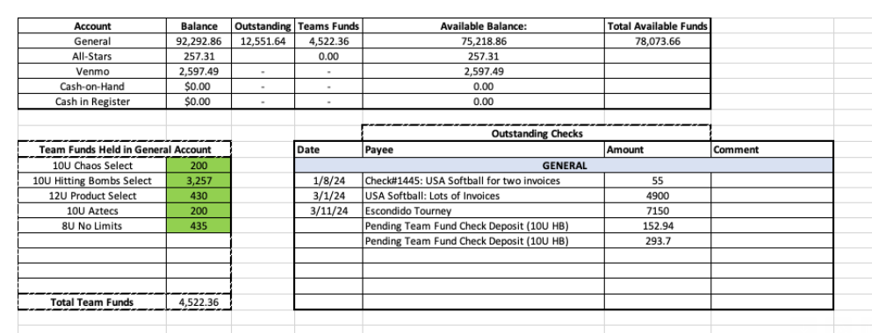
Complaints
- Friday, 3/11 incident on field 4 – intoxicated parent during a 10U game
- Sunday, 3/12 SSD Winter Select Tournament incident between EC and Santee
- Sunday, 3/12 – 12U parent complaining about a manager not playing a player enough innings and always batting that player last
Rule Change Committee – Bryan, Felicia, Alexis, Lance – looking at the number of innings that players must play in each game –
Snack Bar – Shifts begin at 4:30 pm during the week effective immediately
All Star tournament schedule being finalized
League will pay for Gold for districts – Silver/Bronze will pay their way
League pays for all teams at State, Nationals & Regionals
Escondido Tournament – only pay for Gold teams

Meeting Adjourned: 8:51 pm
Next Meeting: April 8

