Baseball Booster Meeting 10/15/25

Meeting called to order by: Tara Lampman Time: 6:32 pm
Members present: Coach Kasey Bass, James Georgakas, Stephanie Jensen, Lisa Acker, Casey Miller, Tara Lampman, Donnie Sabe

Approval of Prior Meeting Minutes: Meeting, 9/3/25 were reviewed, motioned to accept 9/3/25 meeting notes/agenda by Lisa A, Casey 2nds: All Agreed. Meeting notes were approved

Officer’s Reports:
Treasurer’s Report:
- Bank Transactions:
- 2025/2026 Annual Budget:
  - Changes in Coaches
- Motioned Tara, Stephanie 2nd

Committee’s Reports

Old Business:
Booster Bylaws:
- Review & Approval of Rough Draft
  - Corrections need to be made, Tara will make corrections and resend to Board Members and Coaches via email
  - Secretary needs the Bylaws for Bank

Fundraiser Updates:
- Meat Raffle @ SABES - Lisa
  - Scheduled for 2/14/26 @ 3 pm
- BINGO @ SABES - Casey M/Donnie S
  - 1/11/26 @ 1 pm
  - Send Email to Parents to sign up in November 2025 for them to sign up.
    - $50/$100 buy in
- Salt Drive w/ Ace Hardware - Coach Bass
  - Bass will talk with Owner of Ace Hardware
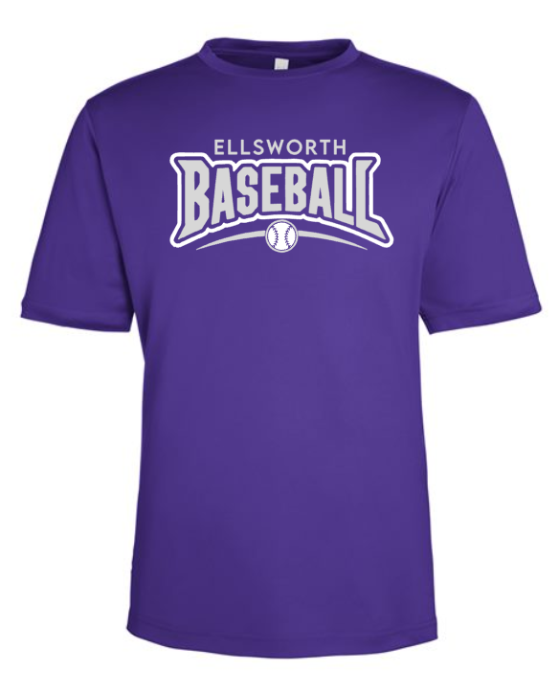
Apparel Updates:
T-shirts -
- Practice T-shirts (Tara)
- Brush Strokes bid $12.50 per Tshirt
  - Can be any color?
  - 60 T shirts
  - Mid March
  - Coach Bass is getting a player meeting together for the first couple weeks of November to gain interest. He will have them sign up with clothing sizes at meeting

Uniform Updates - Steph J & Coach Bass
- Steph showed Purple, Black and White Jerseys from CV-Sports
- $1300.00 for 20 uniforms

New Business:
New Nominees & Voting
- President - Tara Lampman
- Vice President - Stephanie
- Secretary - Casey Miller
- Treasurer - Lisa Acker
All Positions will take effect 11/1/25. No nominations were received by email.

Announcements:
Coaches Announcements -
ManCave BINGO
Meat Raffle

Next Meeting: 11/11/25 @ 4:30 pm @ Bros

Adjournment:Meeting adjourned at 8:26 pm by President Tara Lampman

