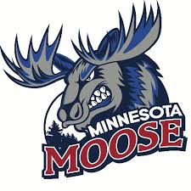
Journalism Intern
The Minnesota Moose Hockey Club, located in Blaine, Minnesota, is seeking a motivated and passionate Sports Journalism Intern to join our media team for the 2025-2026 season. This internship will provide valuable experience in sports journalism, with a focus on covering game-day events, writing articles, player interviews, and producing content for the team’s website. The intern will have the opportunity to build a portfolio while gaining hands-on experience in sports reporting and media relations.
Key Responsibilities:
- Write game previews, recaps, and feature articles for the team’s website and social media channels.
- Conduct interviews with players, coaches, and staff, and write compelling stories based on those interactions.
- Assist in writing and editing content for team newsletters, press releases, and media guides.
- Attend home games to cover key moments, team dynamics, and fan reactions.
- Assist with the creation of social media content (text, graphics, and video) to engage fans and keep them informed on team news and game-day activities.
Required Qualifications:
- A strong passion for hockey and sports journalism.
- Excellent writing, editing, and communication skills, with an ability to produce clear, engaging content.
- Basic understanding of hockey, its rules, and the Junior hockey landscape.
- Comfortable conducting interviews with players, coaches, and other team personnel.
- Availability to work evenings, weekends, and some holidays (game days).
Compensation and Benefits:
- Must be a technical, undergraduate, or graduate student enrolled in a college credit internship program, preferably pursuing a degree in Journalism, Communications, Media Studies, or a related major.
- Hands-on experience with sports journalism and content creation for a Junior hockey team.
- Networking opportunities within the sports and media industries.
- Team merchandise and tickets to games.
How to Apply:
To apply, please send your resume, writing samples (e.g., articles or blog posts), and a brief cover letter explaining why you're interested in the Sports Journalism Internship with the Minnesota Moose to mnmoosecoach@gmail.

