Roosevelt Athletic Booster (RAB) Club Meeting
Minutes: 3/8/2021
Location: Zoom, 7:00pm
RAB website: https://www.rooseveltathleticboosters.org/

- Meeting Hosted by: Stephanie Welsh, Secretary & Colin Ryan, Treasurer
- Attendance – 14 reps were in attendance (*see section at end of minutes)
- Upcoming meeting: April 12, 7:00pm on Zoom
- February Minutes approved
- Treasurer’s Report
  - Monthly spreadsheet was distributed by Colin on March. 8, 2021
  - Things are starting to pick up a little now that sports season 1 is going.
  - Colin doesn’t yet have access to Greater Giving, so some donations aren’t reflected in the spreadsheet yet. He’s working to get access.
  - Amy Olason (cheer) has a grant request coming.
  - Ken Tousley (boys lacrosse) will likely make a grant request for equipment to make the RHS football field safe for LAX use (with girls LAX).
  - Stephanie will send grant request paperwork to Cheer & LAX teams.
- Streaming RHS Sports
  - Arden did research on a variety of ways to live stream sports, but in the end she and John Chung put together a simple but elegant solution that is free to spectators:
    - Technology: laptop, camera, microphone, hotspot
    - Software: laptop/camera software & YouTube
  - John video-taped the game and posted it to YouTube, then Arden sent the link out to all the parents.
  - A discussion ensued about how simple the set-up was, and how it was fairly cost effective (Football bought the laptop, John let them use his camera and hotspot.)
  - There was general agreement that streaming RHS Athletics is not just something to do during a pandemic, it will be part of athletics in the future. It gives all sorts of people more access to RHS sporting events...fellow student athletes, grandparents & relatives who live elsewhere, parents who can’t make it to the game live.
  - A few challenges to consider:
    - Lack of Wifi or ethernet at certain venues. John used his personal hotspot for Football, but that only works with good cell coverage.
    - Indoor pools and inclement weather could be damaging to equipment, or may need additional protective equipment.
    - It takes YouTube 24hrs to provision the studio link, so some planning is needed before first video streaming.
    - The camera on the iPad doesn’t have a great zoom, so it can be challenging as the primary piece of technology. There may be a way to connect a camera to an iPad for recording purposes.
  - Arden suggested and many agreed that having a streaming “kit” (a bag with all the relevant parts in it) could be shared by several teams. Football is willing to share their kit when they are not using it.
  - It was proposed that in the future maybe high schoolers who are good with technology (frankly, most of them are better than us) could take over the videoing and posting to YouTube. It could qualify for community service hours and/or be a club.
  - RAB could potentially purchase another streaming “kit” for use by other teams when games/meets/competitions overlap. But first we need an analysis of how often we have scheduling conflicts before we consider purchasing equipment.
  - Somewhere in the middle of this discussion, the RAB meeting was Zoom-bombed by Barry!
  - John & Arden will send Stephanie the list of what equipment they used and a general outline of instructions on what they did. Stephanie will add a ppt tutorial on using YouTube to the packet and then provide it to RAB for discussion at our next meeting.
- Honoring Senior Athletes
  - Karen and Melanie analyzed our ideas about honoring the senior athletes with a slideshow for the whole school and came to two conclusions:
    - There are 150+ senior athletes and it would be difficult and time consuming to track them all down to get photos and info.
    - It’s more meaningful for the kids to be honored within their own team communities, rather than generically as a senior RHS athlete.
  - There was general agreement that RAB should encourage individual teams to do their own celebrations of seniors, and if RAB can help financially or otherwise, we will try to do that.
  - The idea of providing a Senior Memento was also modified after discussion.
    - Originally, we considered providing t-shirts, but feedback from the kids is that they are not going to wear them when they go off to college or their post-HS life.
    - Arden brought up the idea of how athletes used to “letter” in sports and get a physical letter, leading to a new memento idea:
      - Design and print a sticker that looks like the traditional RHS “R” or maybe a special “R” and give them to the senior athletes. We might be able to get smaller stickers representing the different sports or the years they lettered to add onto the R sticker.
    - Stickers will be relatively inexpensive and kids could put them on laptops, water bottles, scrapbooks, etc.
    - Karen will ask Kirsti Rochen about possible help with design and sticker suppliers.
    - Below is an example of a special letter R that used to be earned by athletes who won Metro League, provided by Melanie Ridenour:
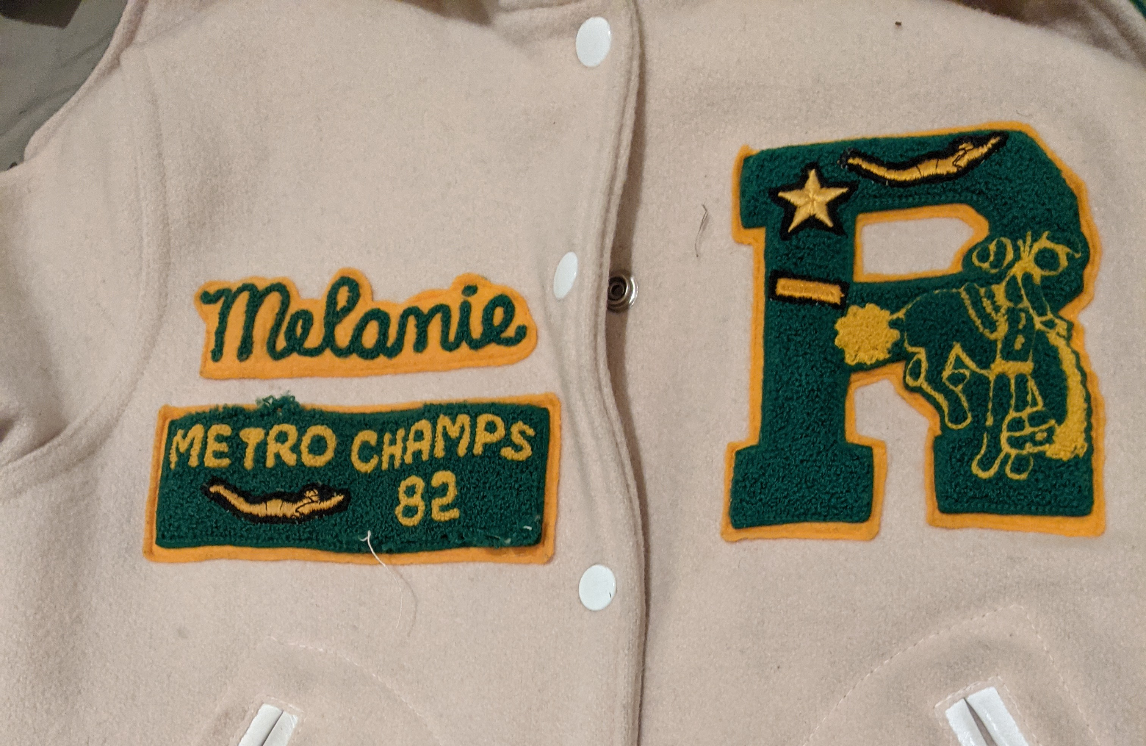
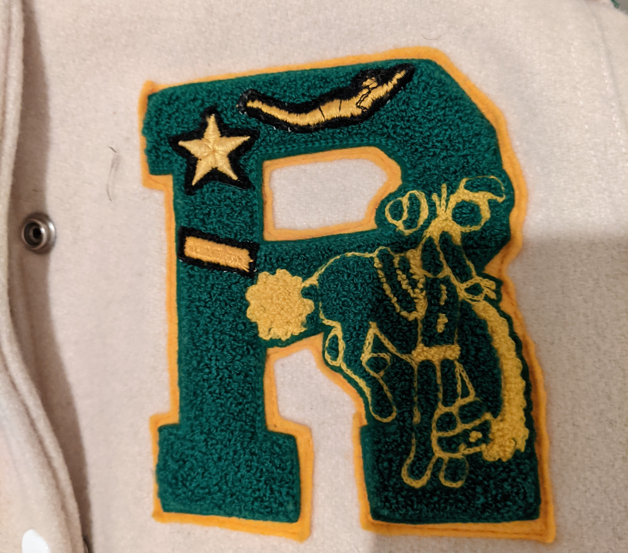
- Fundraising – Low-key approach
  - During the February meeting we discussed taking a low-key approach to fundraising and keeping it simple: create a direct appeal (couple sentences) and put it in the RHS e-News and send it out to the teams. It would send people to the Donation page our the RAB website (which would be updated to reflect the direct appeal language).
  - Karen proposed that instead of focusing on low-key fundraising for our last two meetings of the year (April & May), that maybe we focus on rebuilding RAB into a more robust organization. She suggested:
    - Finding committed reps for every RHS sport
    - Getting new officers lined up for next year
    - Recruit some members with special skills – web design/updates, AV, fundraising, etc.
    - Update the website (check out Ingraham’s booster website: https://www.ingrahamathletics.org/home)
    - Make a PLAN for next year including fundraising and community-building events.
    - Take advantage of the spring to plan something really great for Homecoming – plan an event that has the spirit of the Champs Night we did last spring but takes advantage of everyone being excited to be back to school and sports in the fall
    - Revisit some ideas about what the Booster Club should be involved with, such as the RHS Sports Hall of Fame
- Attendees:
  - Stephanie Welsh – secretary, dance
  - Colin Ryan - treasurer
  - Lisa Hagan- girls swim and dive
  - Kristen Chung- wrestling
  - Arden Erickson- football
  - Suzan Mazor- boys track
  - Tae-Hee Han – baseball – Tae-Hee announced the transition from Ron Weber to Gary Basse for the
  - Gary Barss - baseball
  - Karen Thiers – girls basketball
  - Ken Tousley- boys lacrosse
  - Melanie Chin Ridenour – boys basketball
  - Casey Lougheed – Athletic Trainer
  - Sara Swanson – boy basketball
  - Rod Tarrago– boys lacrosse
  - John Chung – special guest of Arden, shared streaming info with us

