

NERVA Membership for Coaches

Steps to renew/purchase mandatory NERVA membership:
- Visit the SportsEngine NERVA membership registration page here.
- In order to proceed with registration, you need to have an active SportsEngine account. If you are already signed in to SportsEngine, you will see an option to click your name/profile to proceed to registration. Otherwise, you will need to sign in or create an account. Those with existing accounts should sign in. Others will need to follow the on-screen prompts to create a new SportsEngine account.
- If you needed to create a new SportsEngine account, use the link mentioned in step 1 to return to the registration page to sign in (if needed). Once signed in, the next page will ask who the membership is for. Click your profile or the applicable profile for who’s NERVA membership you are renewing.
- On the following page, enter or confirm your information. Once finished, click .
- The following page will ask how you anticipate participating in the coming season. Please select coach and then click . If you participate in multiple roles, select the primary way you will participate.
- This should be the only option on the next page, but in any case – select this option before proceeding to the next page.
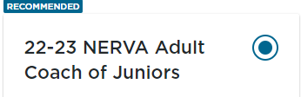
- The next few pages ask for more personal information and check some boxes agreeing to having read privacy terms, signing waivers, etc. Just follow the on screen prompts here.
- You should then reach a page confirming which memberships you are paying for. These should be the memberships:
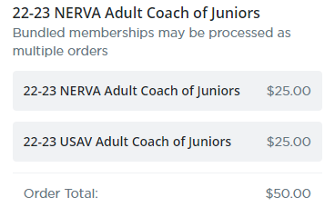
- Follow the prompts on the next pages to complete the $50 payment for the memberships mentioned above.
- Once completed, you should reach a confirmation page. There are other requirements so use this button to go to your My SportsEngine page:

- On the next page, look for this yellow box on the right-hand side. If it says ineligible, please click “Complete Requirements”.
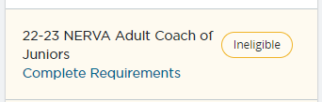
- On the next page, look for this expandable bundle and click the arrow to the left of 22-23:
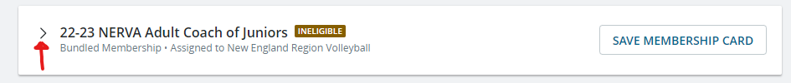
- Once expanded, you should see several lines of requirements each with status icons to the right of the line indicating whether it is complete, paid, required, expired, etc.
- From here, it is required to complete all outstanding/required/expired items prior to the start of the season.
- Please reach out to SCVBMike@gmail.com or SCVBTomP@gmail.com with any issues or questions.

