INDUCTEE
Thomas Caldara ’90
Tom Caldara, a 1990 Ardsley graduate, was born in Yonkers and is the youngest of five boys. Playing sports began with tackle football in the living room followed by endless sports/games in the backyard. Growing up in the Caldara home with a sports loving family often felt like one, non- stop pick up game. | 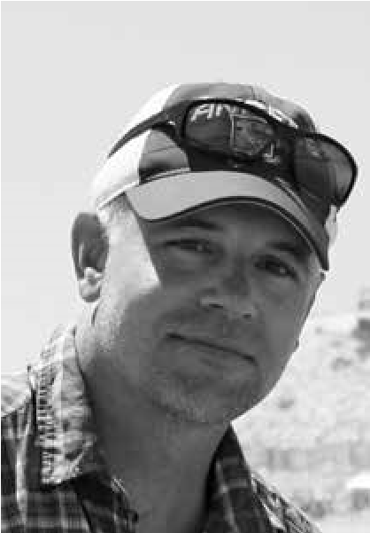
Tom’s father Bart graduated from Dobbs Ferry High School (’48)
and was all county in three sports (football, basketball & baseball), earned a football scholarship to Ryder College and played baseball in the Brooklyn Dodgers organization. A passion for sports was passed on to his five sons and Bart rarely missed one of their games. Tom’s mother Pam enjoyed sports growing up as well, managed the family chaos while working two jobs and was the glue that kept the boys together.
At Ardsley High School, Tom played three years of varsity football. As a running back and defensive back, he was named team captain and MVP in his junior and senior years while earning All League and All Section honorable mention in ’88 and ’89.
Tom’s Ardsley High School baseball career included a trip to the state tournament all four years of high school. His teams won three consecutive state championships from ’87-’89. In his senior year, he helped Ardsley win its 6th straight section title, losing to the eventual state champions in the state semifinals. Tom was a second baseman (and closer) and was named New York State Tournament MVP in ‘89, Westchester/Putnam Rockland Player of the Year in ’90, was a two time Daily News All Star, All State and an All American. Tom earned a full baseball scholarship to Fordham University where he was two time All Patriot League, Northeast College All Star and also played in the NCAA tournament.
After graduating from Fordham with a bachelors degree in science, Tom spent 5 years working in marketing in New York City. He then decided to make a complete career change, going back to school and earning a masters degree in School Counseling from the College of New Rochelle. Tom began working in education at his alma mater as a school counselor at the Ardsley Middle School in 2003. Since then, he feels lucky to have worked with countless families and kids, doing his best to help them navigate the challenging middle years. In addition, he has been a volunteer for Ardsley’s varsity baseball team, coaching with his brother Jeff, who two decades ago, took over for the great head coach Neil Fitzpatrick.
Tom and his wife Kim have two children who attend Ardsley Schools, Lily, 14 years old and Nate, 11. This past spring, Lily played second base for the Ardsley girls softball team that won the first state championship in school history. Ironically, exactly thirty years prior, Tom was the second baseman, for the last of Ardsley’s state championship baseball teams in ’89. Nate is an avid sports fan himself, enjoys playing baseball and basketball and is the equivalent of a sports encyclopedia. Tom and Kim enjoy running, music, vacations in RI and their young Golden Retriever Riley.
Tom feels that being the youngest of five boys gave him an edge on the field as he was forced to attend countless games during his younger years. Along the way, he learned valuable lessons about sports and life. Tom’s fondest baseball memory to-date was being able to form the double play combination for the ’88 state championship team with his brother Jeff whom he had admired and looked up to during those formative sports years.

