The 2025 Porter Parent Football Association (PPFA) Newsletter – Week3
The LTHS Porter Parent Football Association (PPFA) is a volunteer group dedicated to enhancing the football experience for players. Our goal is to foster a positive, memorable environment for each player, achieved through support for both the players and coaches. The PPFA funds its efforts through various fundraising initiatives, including spirit wear, player sponsorships, and volunteering.
- Twitter @LockportFootba1 - Facebook @ LTHSFootballBoosters  - Lockportfootball.com
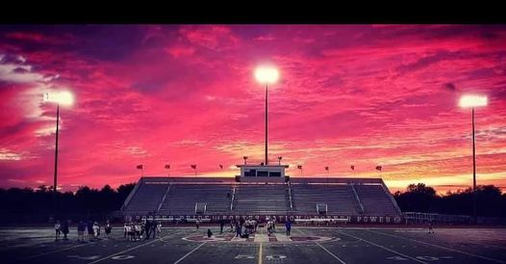Every Week
Varsity Players Pasta Dinner – Every Thursday @ Cooms Corner
Week3 Pasta Dinner: 9/11 @ 4:30pm **Parent Volunteer and/or Dessert Donation**
** Ask-a-Porter ** - 10Q with Adam Kozak
Game Schedule/Results
Varsity: Porters vs Homewood-Flossmoor: Fri 9/12 @ 7:00pm Game Preview
Porters lose to Plainfield North on 9/5 (17-21) Game Recap ** Senior Night Photos **
Sophomore: Porters vs Homewood-Flossmoor: Fri 9/12 @ 4:45pm Porters lose to Lincoln-Way West on 9/6 (21-35)
Freshman A: Porters vs Homewood-Flossmoor: Sat 9/13 @ 11:15am Porters A over Lincoln-Way West on 9/6 (6-0)
Freshman B: Porters vs Naperville North: Sat 9/13 @ 9:00am Porters B lose to Lincoln-Way West on 9/6 (8-28)
News and Notes
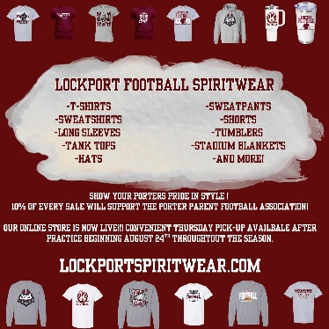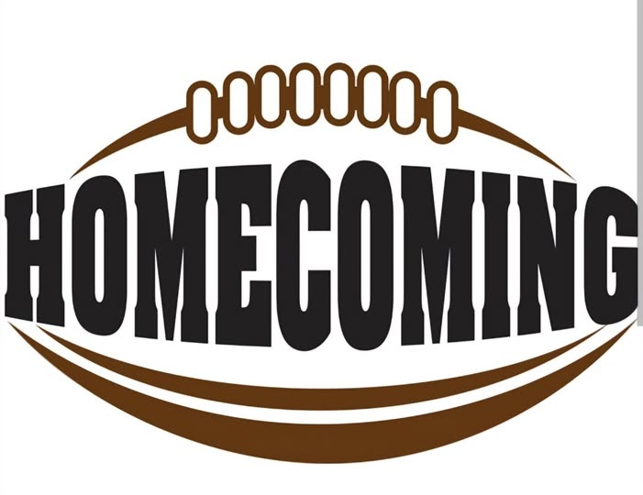
Order your 2025 Lockport Football Spirit wear HERE Homecoming Committee (game 10/3) **Volunteer**

PPFA Board Meeting: 9/16 (Tuesday) @ 7:00pm – LTHS (Porter Room)
Save-the-Date: 10/3-Homecoming 10/31-State Playoffs (first round)
Helpful Links
Spirit Wear Game Digital Tickets IHSA Football Info 8to18

