Dribbling (0-15 minutes)
  - Dribbling Fundamentals
    - Knees bent, light on feet, eyes up, use inside and outside of foot
  - Toe Taps
    - https://www.youtube.com/watch?v=ndMkjRROeMk
      - 3 sets x 20
  - Bells
    - https://www.youtube.com/watch?v=wEHDDBwENJA
      - 3 sets x 20
  - Inside/Outside Touches
    - https://www.soccerdrive.com/soccer-drills/dribbling-skills-series (:11 second marker)
Passing (15-30 minutes)
  - Passing Fundamentals
    - Step into ball (non-kicking foot next to the ball), foot sideways (hockey stick shape), eyes up, drive through the ball
    - https://www.youtube.com/watch?v=fCanpKMKwUI
  - Partner Passing – 2 touch
    - https://www.soccerdrive.com/soccer-drills/first-touch-skills-series
  - Partner Passing – 1 touch
  - W passing
    - https://www.youtube.com/watch?v=3KPh8U416kE&ab_channel=KSPerformance (feel free to stick with the first variation.)

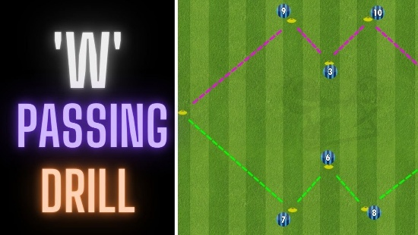 | W Passing Drill | Continuous Passing & Combinations | Football/Soccer  This continuous passing drill is in the shape of a 'W' and offers plenty of combinations. In this video, there are 3 combinations, one starting at each point...  www.youtube.com

Shooting (30-45 minutes)
  - Shooting Fundamentals
    - Step into ball, lock ankle with two down, strike ball with laces (big bone part of your foot)
    - https://www.youtube.com/watch?v=ECospNT9yCM
  - Dribble into a shot
    - Set up 3 lines. Kids will dribble up to a designated spot and shoot with their laces into the goal. Focus on them using the correct part of their foot. Have them use both feet.
  - Competition
    - Same drill but have the three lines compete against each other (first to x number of goals)
Team Portion (45-90 minutes)
Start with teaching all necessary soccer rules... throw-ins, goal kicks, corners, etc.
- 3 Team Possession. Team that loses the ball is on defense, other two work together. Great opportunity to teach spacing for the two teams that are in possession of the ball. Don't be afraid to blow your whistle and stop the play constantly for coaching points, that is the only way they will learn.
  - https://www.youtube.com/watch?v=bJOU2srtH0c&ab_channel=CodeFootball
- 6 goal game. Set up 3 goals on each side of the field. Each team is defending their set of 3 goals and can score on any 3 of the opponent's goals. Focus on switching point of attack.
  - https://www.sportsessionplanner.com/s/UMWT/6-goal-games.html?interface=en (scroll to last image and description)
- Normal 7v7 game to end the day.

