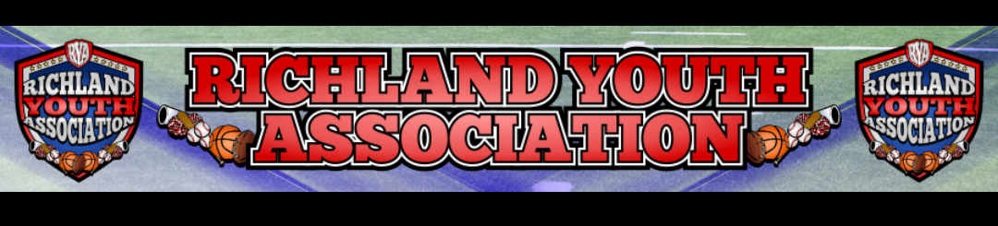
RYA NOVEMBER BOARD MEETING
Meeting Date: November 2, 2022 – 6:30pm
Attendees: Mike Cowan, Ben Earley, Blair Armfield, Richard Stutheit, Lisa Willis, Eric Gomez
Absent: Kevin Vorpahl

General Board Items / Old News
- Damaged scoreboards – need to check breakers in the storage buildings for baseball scoreboards.
- Restitution Payments – no payments made recently
- Elections for all board positions except for President will be at 6:30pm on November 16, 2022.
  - An email will be sent out to RYA membership to solicit additional volunteers to assist with vacant and contested board positions.
  - Currently there are 5 vacant board positions.

Football: Eric Gomez
- Upset parent sent email about 7u program, issue resolved by Eric.
- All 7 RYA teams made it to the NWTYFA Playoffs
  - 4 home games at RHS on 11/5 – 6u, 7u 8u, and 10u
  - 3 teams playing away
- End-of-Season RYA Football Party will possibly be at Birdville FAAC thanks to Coach Kates
  - Letter jackets for all 12u players aging out of RYA - $60/each and will be paid for from gate fees collected during the season.
- Total of $2121 in fees and dues paid to NWTYFA from RYA during the season.
  - RYA Football will review late fees for errors to request possibly refund from NWTYFA.
  - NWTYFA will handle paying officials and retains all gate fees from the playoff games.

Cheer: Lisa Willis
- 8u Cheer Team is doing fundraiser for team.
  - Car raffle donated by car dealership. Raffle will include RYA shield logo, but funds will not be handled by RYA.
- $1010 gate fees turned in to RYA from gate fees collected during 10/15, 10/22, and 10/29 weekends.
- RYA Cheer will review late fees paid to NWTYFA for any overpayments this season.
- Still seeking reimbursements from Cheer Zone for uniform-related issues this Fall.

Rec Baseball: Richard Stutheit
- Final weekend of season rained out and cancelled tournaments for 6u, 8u, 10u, and 12u.
  - Local games played on Nov 1 and Nov 3 to close out season for kids.
  - Rings purchased for all leagues will be held over to the Spring for use then.
- End-of-Season survey conducted via Google Forms and received 33 responses as of time of meeting.
  - Key findings from survey:
    - Survey found that 75.7% had good or great experience with RYA.
    - 81.3% had good or great experience with their volunteer head coach this season.
    - Only 56.2% found umpires used were good or great, with 31.3% rating umpires as okay.
    - 97% of respondents found jersey quality to be good or great.
    - 8 respondents stated they would be interested in being a head coach, 7 respondents were interested in being an assistant coach, 6 respondents were interested in being a team mom/dad, and 1 respondent was interested in either being a vice-commissioner or on board.
  - Key takeaways from survey:
    - More shade needed at Richfield Park for day games.
    - Coaches need to focus on kids having fun and playing the game, but generally coaches had very positive reviews.
    - Umpires were inconsistent in their calls during kid pitch games (10u, 12u) and did not always follow RYA guidelines and rules. A few of the umpires were noted as being impolite with speaking to parents.
    - Parents want more communication up front from league and parent meeting would be helpful at start of season.
  - 1-2 vice-commissioners will be appointed to help manage Baseball program in Spring.

Basketball: Blair Armfield
- Closed registrations with 166 players registered.
  - 27 in 6u, 46 in 8u, 38 in 10u, and 55 in 12u
- Uniform fittings on 11/6 from 3-5pm, some late registrations allowed that day.
- Access gained to host games at North Richland Middle School again.
  - 6u and 8u will still play at The Link
  - One weekend will have games still hosted at Haltom MS (1/21)
  - BISD creating action plan to invest resources in RYA / community
- Zexez contacted about possible team name change (without changing logo) and awaiting response.

Premier/Tournament Baseball: Kevin Vorpahl (absent)
- November tournament did not have enough teams and potential weather causing fields to be closed.

Marketing: Vacant
- Smithfield Elementary School Fun Run delayed to Spring and RYA will use this as Marketing opportunity at that time.

RYA Bank Accounts totaled $44,245.59

Meeting adjourned at 8:35 pm

