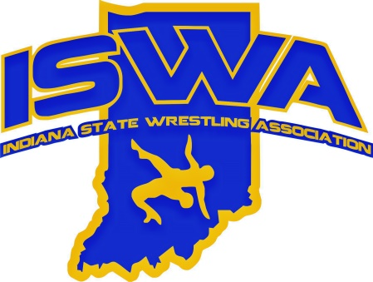
INDIANA STATE WRESTLING ASSOCIATION, INC.

P.O. Box 157, Beech Grove, IN. 46197 Phone 317-780-1885
2024-25 ISWA ANNUAL REPORT

Tournament Committee

We have had a busy year. ISWA started off the year with Elementary Duals. This tournament continues to grow and ISWA is excited to have the interest we do. Middle School Duals and Kids Nationals in Fort Wayne rounded out the winter for us and were tremendous successes. In 2025 we took Folkstyle State to Columbus, Indiana and it did not disappoint. This new location supported the growth we have had in wrestling across the state and was one of the best Folkstyle State Tournament to date. On to Freestyle/Greco! Like all other tournaments, Freestyle/Greco State, continues to grow. the summer, the ISWA hosted the USA Girls National Duals in Westfield, Indiana. 14U,16U and Juniors took the mats at Grand Park. 164 teams from around the country were there.

We are growing! We are excited about that challenge and the opportunities it has for our wrestlers and the sport. These challenges in growth provided so many opportunities for clubs and the wrestling community to be involved in our events. We are always seeking help at events and mats for our events. We hope that the area clubs and wrestling community will continue to help us rise to the growth of wrestling in Indiana.

Thank you to all,

Roby Webster
ISWA Tournament Director

