SLPYHA Board Meeting Agenda
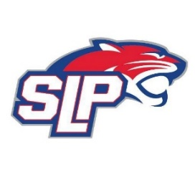
Date: 11/18/20
Zoom
8:00pm

Attendees: Bob Roloff, Scott Lichter, Michelle Rice, Corey Piekarski, Mike Mliner, Jason Shipman, Kevin Mitties, John Pitzl, Jeremy Flaten

Guests: Cindy Tranby

- President Report: Bob Roloff
- Call to order: 8:00pm
- Approve agenda
- Approve minutes from 11/10/20 meeting, motion: Rice, move: Shipman
- D10 Updates
- Vice President Report: Michelle Rice/Scott Lichter
  - COVID – Guest, Cindy Tranby
  - How do things look going forward?
- Treasurer Report/Gambling Report: Mike Mliner
  - Panther Classic cancelled
  - Shut down pulltabs
  - Refunds for the tournament and shut off payments for association members
- Secretary Report: Corey Piekarski
- Traveling Director Report: Jason Shipman/Chris Mueller
- Girls Traveling Director Report: Kevin Mitties
- Mite Director Report: John Pitzl
- Coaching Director Report: Jeremy Flaten
- New/ongoing Business:
- Motion to dismiss: 9:37pm, motion: Flaten, move: Mitties

