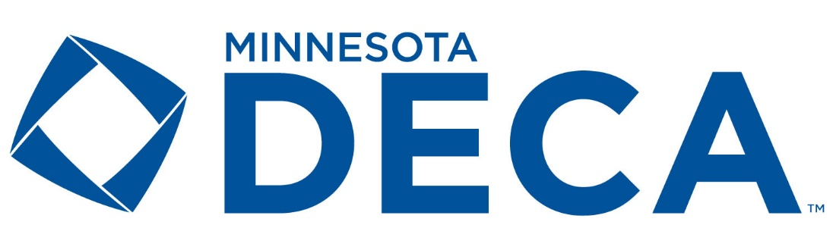
WRITTEN EVENTS DEADLINE
THURSDAY, FEBRUARY 20, 2025
Requires an Electronic submission due by 11:59 pm CST on February 20, 2025. AND a hard copy submission at the time of the preliminary round of presentation. The hard copy submission must be in an official DECA folio and include all elements

ALL projects, both 10 and 20 pages will be uploaded as a pdf to the Level 8 State Conference Registration System (where you register for State).
- Advisor is responsible for uploading the projects. Students do not have access.
- Penalty Point form should NOT be included in the pdf
- Statement of Assurance must be signed & included.

NAMING OF PROJECTS
Name however you can keep track of – no need to rename in any format as the system renames according to the id number of participant that the system has. You do not need to take time to rename. Be sure to verify after submission that you uploaded the correct student(s)’ project.

STATEMENT OF ASSURANCE
The written statement of assurances can be found in the DECA Guide on the DECA Website.
The document must be printed out, completed, scanned and then uploaded as a PDF.

Statement of Assurance can be included in the event submission process in two ways.
- Have as part of the pdf of the written project at the beginning of the document scan.
- Have as a sperate document and there are two upload button/function to include separately.

How to Submit Written Projects
Advisors must upload their student’s written projects & Statements of Assurance. 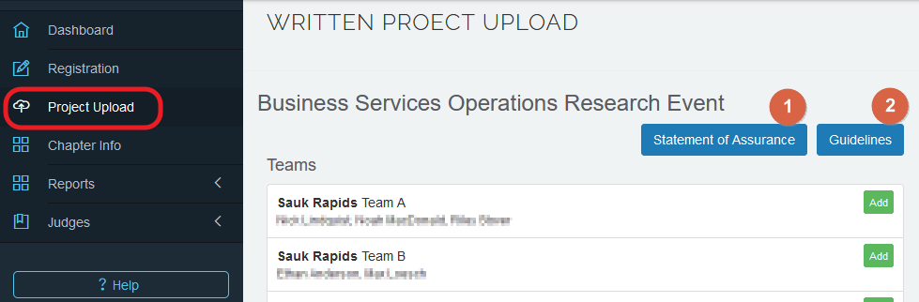

- Click on Project Upload in the main navigation
All events that have project uploads will be listed, with your registered teams listed
  - Option to download Statement of Assurance (pdf) and event Guideline (pdf)
- To upload files, click Add for the Team
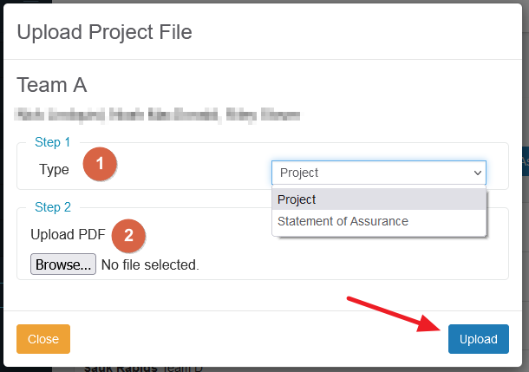

  - Select upload type (Project or Statement of Assurance)
  - Select PDF
  - Upload

- Files will be shown and viewable once uploaded. If you need to replace a file click Remove and then upload again.
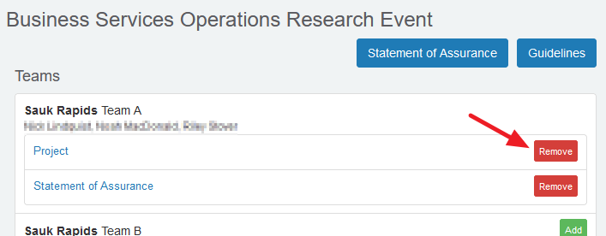

Events electronic submission is required for 20 page projects:

*No printed copies are turned in at State.

EBG BUSINESS GROWTH PLAN
EFB FRANCHISE BUSINESS PLAN
IBP INTERNATIONAL BUSINESS PLAN
EIB INDEPENDENT BUSINESS PLAN
BMOR BUYING & MERCH. OPERATIONS RESEARCH
BOR BUSINESS SERVICES OPERATIONS RESEARCH
FOR FINANCE OPERATIONS RESEARCH
HTOR HOSPITALITY & TOURISM OPERATIONS RESEARCH
SEOR SPORTS & ENTERTAINMENT MRKT. OPERATIONS
PMBS BUSINESS SOLUTIONS PROJECT
PMCD CAREER DEVELOPMENT PROJECT
PMCA COMMUNITY AWARENESS PROJECT
PMCG COMMUNITY GIVING PROJECT
PMFL FINANCIAL LITERACY PROJECT
PMSP SALES PROJECT

10 PAGE PROJECTS ONLY:
- Must bring a printed copy to the preliminary competition in a DECA folio or blue 3 ring binder, hand to, and leave with judge
- All printed copies will be collected and put on a table for Monday night advisor get-together. No sorting will be done by Event Chairs. Advisors must retrieve if they wish.
- Suggested that students bring 2 copies to SCDC

Events electronic submission is required for 10 page projects:
ESB START UP BUSINESS PLAN
EIP INNOVATION PLAN
IMC INTEGRATED MARKETING PLANS -ALL AREAS
GLD GOLD CHAPTER CAMPAIGNS

Remember, all DECA event manuals must include completed “Statement of Assurance” or project will receive 15 penalty points – as per the National DECA Guidelines and the MN DECA Board of Directors. A copy of the statement of assurance can be found in the National DECA “Guide”.

Pre-submission is not required for:

SBE SCHOOL BASED ENTERPRISE does not need to be submitted electronically. It is an interview only at State. No materials required.

