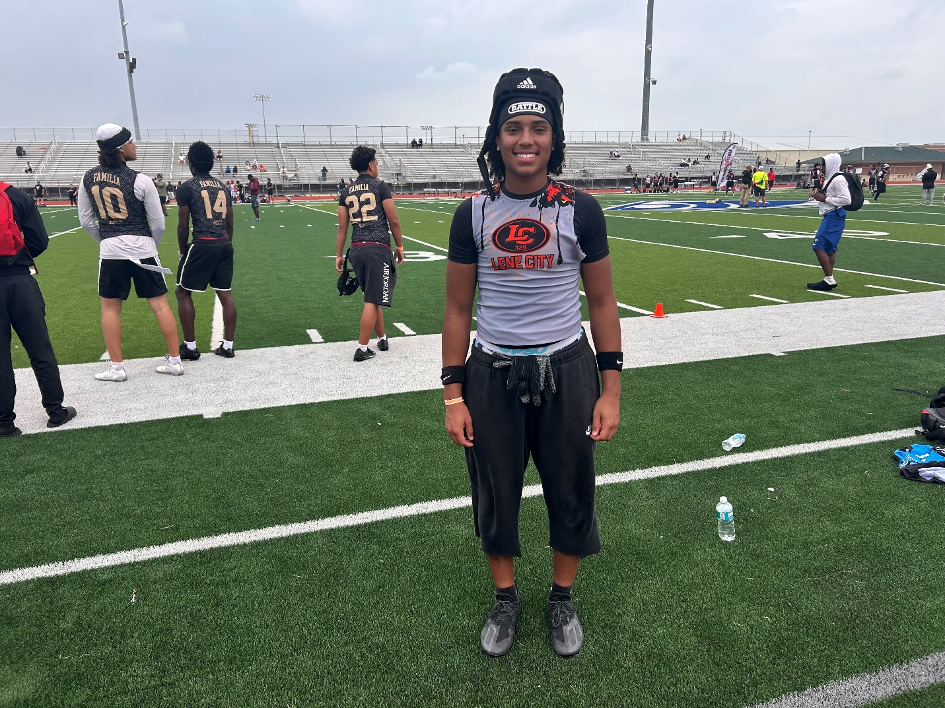

Camrin Allen’s Two-Way Talent Fuels Rising College Recruitment
  - 2027 Abilene High School | Abilene, Texas | 5-foot-11, 165 pounds | Wide Receiver / Defensive Back
Camrin Allen is emerging as a versatile college football prospect whose athleticism translates to both sides of the ball. The 2027 Abilene High School standout has built recruiting momentum through his high school season, camp performances and productive work on the 7-on-7 circuit.

Recruiting Momentum
Following a successful 2026 Friday night season, Allen has received college offers from Cornell University, the College of St. Scholastica, Capital University, Kansas Wesleyan University, Community Christian College and McMurry University. His performance at a McMurry camp helped secure that offer, while appearances at William Jewell College and Hardin-Simmons University provided additional opportunities to compete in front of college coaches.

A True Two-Way Prospect
At wide receiver, Allen combines developing route-running knowledge with a 72-inch wingspan, giving him useful reach at the catch point. His camp testing and position work at William Jewell drew attention from additional college coaches, including representatives from Baker University.
On defense, Allen brings an understanding of hip and shoulder movement that supports his work in coverage. That combination of length, movement skills and positional flexibility gives college programs multiple ways to project his development.

7-on-7 Success and National Recognition
Allen also made an impact for Lene City 7v7 on the PremierEventsUSA circuit. His season culminated at the PremierEventsUSA Nationals in Fort Worth, where he was named the 18U Tournament MVP by lead scout Wesley “Buckets” White.
That showing helped him to receive camp invitations from William Jewell, Baker University, McPherson College, Kansas Wesleyan University and Revive Performance’s National Combine Camp. White also nominated Allen for the AEX All American Bowl in Bradenton, Florida, an event scheduled at IMG Academy and designed to bring together selected players from across the country.

What Comes Next
As Allen continues developing with Abilene High School and Lene City 7v7, his combination of two-way ability, length and competitive experience should keep him on recruiting boards. Future tournament travel is expected to create additional exposure to programs in Kansas, Missouri, Iowa and Texas as he works toward the next level.
Article By:
Wes “Coach Buckets” White
National Scout/Recruiter PremierEventsUSA
Email: wes_white2001@yahoo.com
X: @PreWarWesley
IG: @wes_white2001
FB: Wesley White

