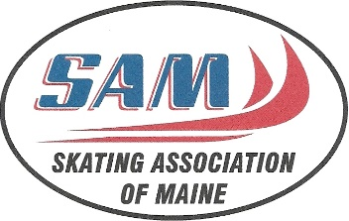

Treasurer’s Report
May 15, 2022

The Skating Association of Maine has wrapped up another successful Fall/Winter season. With COVID restrictions lifted we were able to get back to a more normal season and welcomed skaters from many communities throughout the state to be a part of our many teams and classes.
This year the Association held a variety of fundraisers that contributed to our scholarship and education programs and we thank all of our SAM members for their participation in these efforts. We also had support from local businesses and community members and we appreciate their continued help in keeping youth involved in skating and hockey.
We congratulate all of our SAM members for their achievements again this year. Our figure skaters were part of successful competitions, exhibitions and test sessions and our hockey teams enjoyed a great season and competed for various state and local titles. We are proud of all their accomplishments and successes this year and look forward to seeing them back on the ice soon.
Happy skating,
Heather Knowles,
Treasurer

