CHART 2: Diagnosed Concussion - Stages and Responsibilities

Student:
CONCUSSION DIAGNOSED

Student returns to school to begin the School Concussion Management Plan – Return to School (RTS) and Return to Physical Activity (RTPA) Plan(Appendix C-5) – completed at school
Home Preparation for
Return to School (RTS)
and Return to
Physical Activity (RTPA) Plan (Appendix C-4)–
completed at home
Parent/guardian:
Reports to principal/designate that student has completed:
- Stage 2 RTS
- Stage 2b RTPA

Principal/designate:
Informs appropriate school staff of the diagnosis, and meets with parent/guardian to provide and explain the Home Preparation for RTS and RTPA Plan (Appendix C-4)

Principal/designate:
Meets with parent/guardian to: provide and explain the purpose of Appendix C-5,explain the Collaborative Team approach and their role on the team

Student:
Returns to School
Student conference to develop RTS and RTPA Plan

Return to School –
Stage 3a
Student: attends school (2 hours) with adaptations of learning strategies and/or approaches

Return to Physical Activity –
Stage 3
Student: simple locomotor activities/sport-specific exercise
to add movement

At the completion of each stage student progress is documented with results shared between school and home. Parent/guardian confirms completion of each stage by returning C-5 with a signature.At each stage student is monitored for return of symptoms, new and worsening symptoms. During RTS Stages 1- 4b and RTPA 1-4, if the student exhibits/reports return of symptomsor newsymptoms student must return to the previous stage for a minimum of 24 hours. If during any Stage the student exhibits or reports worsening symptoms, student must return to medical doctor/nurse practitioner.
Return to School –
Stage 3b
Student: attendsschool(half time) with moderate workload

Return to School –
Stage 4a
Student: attends full day school with adaptations of learning strategies and/or approaches

Return to Physical Activity –
Stage 4
Student: increase physical activity, non-contact training drills to add coordination and increase thinking

Collaborative Team Lead/Designate:
Report to parent/guardian completion of Stage 4b RTS and Stage 4 RTPA and provides Documentation for Medical Clearance (e.g., Appendix C-6)

Return to School –
Stage 4b
Student: attends full day school without adaptations of learning strategies and/or approaches
RTS - Complete

Parent/guardian:
Provides principal/designate with signed Medical Clearance (e.g. Appendix C-6 )

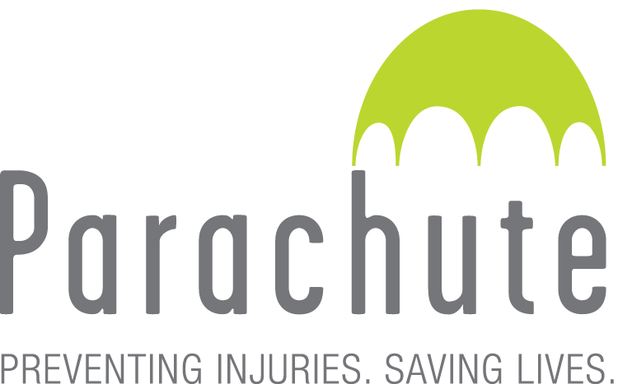
© Ophea 2018

Return to Physical Activity –
Stage 5
Student: full participation in physical activities (physical education, intramurals, non-contact interschool sports) and full contact training/practice in contact sports

During RTPA Stages 5 and 6, if student exhibits a return of symptoms or new symptoms the student must obtain Medical Clearance reassessment
© Ophea 2018
Return to Physical Activity –
Stage 6
Student: unrestricted return to contact sports
RTPA - Complete
© Ophea 2018
© Ophea 2018
© Ophea 2018
© Ophea 2018

