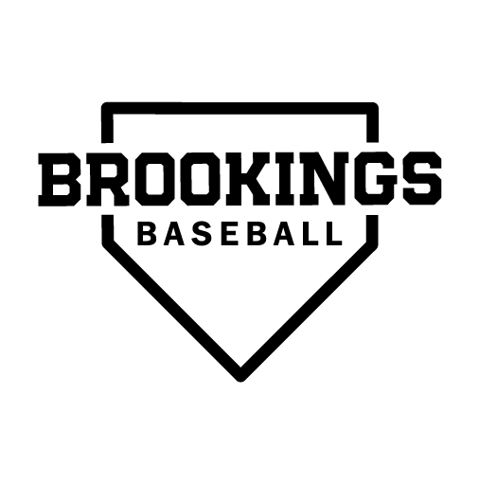
FRIENDS OF BROOKINGS BASEBALL
Board of Directors Annual Meeting – Agenda
Monday, Oct. 17 | 7:30 p.m. Cubby’s (Back Room)

Call to Order:
  - Meeting call to order
  - FOB Board and members present
    - Mike Lockrem, Josh Jones, Melissa Wagner, Graig Reicks, Jon Meendering, Michele Coffell, Karla Hunter, Carter Roach, Matt Hanson, Shawn Helmboldt, Brady Diercks, Kelly Conrad, Adam Porter (guest), Tony Sonnenburg (guest).
  - Additions to the agenda
    - Mike Lockrem made a motion to add Adam Porter as 12u Director, with Josh Jones providing a second. Motion passed.

- Secretary’s Report: Approval of September minutes (Handout Online). Kelly Conrad made a motion to adopt Sept. minutes. Josh Jones seconded. Motion passed.

Treasurer’s Report:
  - 2022 Season Financial Report
    - Total income for the year was $367,499.65, with 256,163.43 in total expenses, for a net operating
income of $111,336.22.

Old Business
  - A site had been set-up for background checks.
  - ATM at Bob Shelden no longer there because it costs $5000/yr.
  - We received some insurance for the scoreboard storm damage, however, we didn’t get the grant from Legends.

FOB Awards Program
  - Bob Shelden Award for Excellence
  - Wayne Hauschild Sportsmanship Award

Registration
  - Registration
    - Oct. 1 to Dec 15 - Update

2023 FOB Hosted Tournaments
  - June 9 - 11: U9 - U12 Cubby's Bar and Grill Tournament (SL, JL, U13/14 White teams not available)
    - Certified umpires for U10, U11, U12
    - Should we require U14 Black & U16 Bullets umpires for the U9 brackets or make it optional for them? This idea will be tabled.
  - June 16-18: U13 and U14 Cubby's Bar and Grill Tournament
    - Certified umpires
  - June 23-25: U13/U14 Cubby's Bar and Grill Tournament
    - Certified umpires
  - July 7-9: U9-U12 Buffalo Wild Wings Tournament (U13, U14, U16 not available)
    - SL and JL umpires
  - July 27 - 30: U13 State Tournament
    - Certified umpires
- FOB Handbook

- Uniforms Update
  - Coach Roach and Bauer are going to work with teams on player numbers.
  - Order deadline for March 1 arrival
  - Legion will pay 50% of jerseys for $1500/year for 3 years
  - 13-16u will have red jerseys and the kids will pay for them

2024 South Dakota Class A Legion Tournament Bid
  - Proposal Due January 16, 2023.

South Dakota Class A Baseball Update
  - Bat requirements will change where 14u on down can swing USA, USSSA, BBCOR, or wood
  - 16u, Jr. Legion, and Legion will still be BBCOR

Monthly Coaching, Director, and Coordinator Reports:
  - Spring Coaching/Scheduling Director (Ryan Bauer)
    - Putting schedules together
  - Summer Coaching Director (Carter Roach)
    - Hosting Rapid City Post 22 for three games
    - Attending tournaments in Yankton, SF Dakota Classic, Marshall Wood Bat, and Gopher Classic
    - Winter workouts for all age groups will begin by Jan. 9 at the latest
  - Summer youth baseball update (Matt Hanson)
    - Assistant Summer Coordinator Position
  - Concessions update (Still need someone)
  - Points/Dibs Update (Still need someone)
  - Other

Umpire Update
  - 2023 Season Scheduling

2022-23 Baseball Calendar
  - March 6 - First Day of Official High School Practice
  - June 9 - 11, 2023 - Cubby’s Sports Bar and Grill Classic (U9-U12)
  - June 16-18, 2023 - Cubby’s Sports Bar and Grill Classic (U13-U14)
  - June 23-25: U13/U14 Cubby's Bar and Grill Tournament
  - July 7-9, 2023 - Buffalo Wild Wings Classic (U9-U12 & U16)
  - July 14 - 16, 2023 - U9, U10, U11, U12 Class A State Tournaments
    - 13U State Tournament in Brookings (3rd straight year)
  - August 2-3, 2023 - U13, U14, U16, JL, SL Tryouts

Fundraising
  - Rah Rah
  - Live Barn
  - Discount cards

Advertising / Sponsorship Update:
  - Scoreboard
    - 5 spaces available for renewal
      - Bozieds
      - Hy-Vee (Renewed)
      - Napa
      - Swiftel
      - Town and Country Shopper

  - Outfield fence
    - 32 spaces available (9 agreements and signs)
    - $1000 each (some trade available)
    - List of companies available on Google Docs
    - Confirmed companies on fence: Active Heating and Cooling, Outlaw Graphics, Edward Jones, Brookings Chiropractic, Midco Sports, Brookings Auto Mall, 605 Custom Design, 3M, Brookings Family Dentistry, Mattress by Appointment, Craft, Kubota.

FOB Operations
  - Bylaws revisions (Handout Online)
  - Josh Jones made a motion to only allow the Bylaws be changed the October Meeting each year. Karla Hunter seconded. Motion passed.
  - Josh Jones made a motion to allow the Brookings FOB member serving on the SD Class A Baseball Board to also be a voting member on the FOB board. Michelle Coffell seconded. Motion carried.

FOB Meeting Schedule:
  - Oct. 17, 20022 (7:30 p.m., Cubby’s Sports Bar and Grill)
  - Nov. 21, 2022 (6 p.m., Cubby’s Sports Bar and Grill )
  - Dec. 19, 2022 (6 p.m., Cubby’s Sports Bar and Grill)
  - Jan. 16, 2023 (7 p.m., Cubby’s Sports Bar and Grill) 6 p.m. check registration
  - Feb. 20, 2023 (noon - 1 p.m./5– 7 p.m.) - Back to Baseball Night/FOB Meeting (7 – 8 p.m.)
  - March 20, 2023 (6 p.m. TBD)
  - April 17, 2023 (6 p.m. TBD)
  - May 22, 2023 (5:30 p.m. parents meeting Bob Shelden/6:30 p.m Board Meeting TBD) i. June 19, 2023 (5:30 p.m. TBD)
j. July 17, 2023 (5:30 p.m. TBD)
k. Aug. 21, 2023 (5:30 p.m. TBD)
l. Sept. 18, 2023 (7:30 p.m., Cubby’s) - Annual Meeting

- Meeting Adjourned
Mike Lockrem made motion to adjourn. Melissa Wagner seconded.

