Coaching Micro Soccer

Hello Coaches!

Our goal is to ensure the kids are having a good time and foster an interest in the game. At this age, most of the players are too young for serious skill development, although we can start to introduce simple technical skills like push passes and pullbacks. Our primary focus is to get them comfortable with having a ball at their feet and to get excited about the game. “The game is the best teacher”; if they are having a good time, they will figure out how to play.

If you have any questions or suggestions, you can email the Micro Soccer Coordinator at kccoord@ohsoccer.com

Please read this and share it with your parents. Occasionally, kids will need to be removed from games because they were wearing jewelry or weren’t wearing shin guards. I don’t want that to happen but those rules are in place to keep all of our kids safe.

Safety (REQUIRED AND NOT OPTIONAL)
- No jewelry can be worn by players during practice or games.
- No headers in practice or games. Intentional headers in games will be treated like a handball, with the opposing team receiving a free kick.
- Players must wear shin guards under socks in practice and games.
Coaches will be asked to remove a player who is wearing jewelry or missing shin guards.

Coaching
- Coaching Micro Soccer is not impossible, but you need to be ready for it and do some work. A few minutes putting together a practice plan, will make running practice easy.
- For more resources and training, you can go to the Coaching Education & Clinics page (under Coaches Resources) on the OHSC website: http://www.ohsoccer.com. There, you can find example lesson plans, videos and training opportunities.
- Be enthusiastic with the kids.
- Don’t be on the field during games. Only the players and the referee should be on the field.
- Don’t keep score. This age group is about playing the game and we don’t care who wins or losses. The kids will keep score; that's fine.
- In the case of a blow-out, work with the other coach to try to make the game fun and competitive for everyone.
- the side that’s down can add players.
- the team that’s up must make 3-5 passes before shooting.
- everyone on the team that’s ahead has to touch the ball before anyone shoots.
- the team that’s up only score goals left footed.
- put a penny on your best player and have them play for the other team.
- Typically, it’s one or two players that are dominating. Try to challenge those good players to get the rest of the team
more involved.
- Ask the referee for permission to sub players when the ball goes out of bounds or during a kick-off. When you substitute, make the player going on tell the player they are replacing. The kids aren’t listening for this from the sidelines. It works well at this age to simply substitute the entire field.
- Try to recruit one of your parents as an assistant coach. More can be helpful with this age group. Please be aware that any person acting in the capacity of a coach or assistant during practice or games must have passed the coaching certification process.
- If you want, it can be good to involve eager parents in the process of managing the team. For instance, having a person to send team emails or post the schedule on Sportsengine.
- Keep the play clean and fun. No slide tackling and if any incidents start to get out of hand, pull the players out and talk to them.
- Remember this is about fun for both you and the kids.

Referees
- All of our referees are club kids, and are as young as 4th grade. It’s a hard job, and can be intimidating. For many it’s their first time refereeing. It’s even harder when an adult tells them that it’s OK to make an exception for one of the players to play with earrings or no shin guards. It is not OK.
- This is sometimes their first real position of authority and confidence can be an issue. I expect our coaches and parents to be supportive.
- Be supportive. Suggestions to them at halftime and the end of the game can be helpful, but make sure you are not intimidating. Most just need to be encouraged to blow their whistle.
- If there are any issues, let the Micro Soccer Coordinator know about it after your game or through email.
- Discourage your players from arguing with the referees and encourage your players to thank the referee after the game.
- The referees should be the ones running the games and not looking to you for decisions.
- Remind your parents about supporting our referees.
- Any call a referee makes is the right call. Even when it’s the wrong call, it’s the right call.

Parents
- We cheer for our players, and never against the other team. I know that coaches have a lot to handle with a team, but please encourage your parents to cheer for all our players.
- Never criticize or argue with one of our referees. Our referees are just kids. If a parent has a concern or complaint about a referee, tell your coach who will bring it up with the Micro Soccer Coordinator.
- Don’t sit along the team’s sideline. Only coaches and players on one side of the field.
- Get your kids to the game a bit early so we can start games on time.
- Remember your raincoats in October.

Equipment
- Required (NO EXCEPTIONS WILL BE MADE)
  - Shin Guards must be worn to practice or play
  - Soccer socks must cover shin guards.
  - NO JEWELRY or metal hair things. Hair bands must be cloth or elastic. Don't get ears pierced right before the start of the season. Earrings cannot be covered with tape or a Band-Aid.
Support the referee if they ask a player to remove jewelry. It happens every year, and the referee has no flexibility in this. Don’t ask for an exception, because no exceptions will be made.
This is not an arbitrary local rule. It's part of the Laws of the Game.
[Law 3] A player must not use equipment or wear anything that is danger himself or another player (including any kind of jewelry).
- Soccer Ball (size 3) issued equipment includes a couple extra soccer balls, but every player should have a ball of their own.
- Shorts without pockets.
- Each player needs to bring a soccer ball to practice. We provide a few of them, but it’s much better if everyone has a ball.
- Cleats aren’t required, but are recommended. No baseball or football cleats.
- Remind parents and kids to bring water to each practice and game especially in the early part of the season.

Remind your parents early on about the jewelry rule. There are no exceptions and players CAN NOT PLAY if they are wearing any sort of jewelry. Our refs are told to enforce this, and all of you coaches need to support the ref when they point this out.

Rules
- No Headers! Intentional headers will be treated like a handball. Don’t practice them, and don’t allow them in games.
- Absolutely no slide tackling or pushing
- Only players and the referee are allowed on the field.
- 3 v 3 with no keeper.
- Coaches are not allowed on the field during games. The only time a coach should be on the field is to help with injuries.
- The field is approximately 20 x 30 yards, with a pug goal at each end. Precise field sizes aren’t important.
- A game consists of two 20 minute halves. Half-time is about 5 minutes.
- No keepers.
  - Players should participate, and play the entire field.
  - Encourage your players not to “camp out” in front of the goal.
- Unlimited substitutions are allowed at any time, but a coach must ask the Ref for permission at a stoppage (the ball goes out of bounds, or after a goal).
- Goal Kick Rule (Retreat Line)
  - A player of the defending team kicks the ball from any point within the penalty area. Opponents must retreat to their own half until the ball is touched by the 2nd player. Please work with your players on going back to the midfield line during goal kicks.
- We do not enforce correctness for throw ins.
  - The important thing is to quickly restart play.
  - Kick-ins are acceptable
- A free kick is awarded for any handball or other foul. There are no yellow or red cards.

Games
- Games start the first Saturday after the start of the new school year, and are played every Saturday for 8 weeks at the Oak Hills Rec Fields.
- Kindergarten plays at 2pm
- First Grade plays at 4pm
- The “Team vs Team” matchups will be sent out a week or two before games start.
- Tell the kids (and parents) to get to the field about 15-20 minutes before the games.
- Make sure they show up at least a half hour early for the first week as we will do team introductions.
- Parents should be on the opposite side of the field from the coaches and players.
- We put down cones, but remind parents not to park along the field side of the street.
- Communicate to the parents early and often to minimize the questions and confusion - and the email to the coordinator. A lot of our Micro Soccer parents are new to this and will appreciate any information you provide. Definitely get the first email out as soon as you have access to your roster to ensure parents they’re on a team.

- We have a new game day setup that is different from previous years.
  - You no longer need to set up your own field cones. Fields will be set up about a half hour before the games start. All coaches need to do is put one goal on each end.
  - The fields are now color-coordinated to show which side you should be on. Parents and spectators should be on the side with GREEN cones and coaches and teams should be on the side with RED cones.
  - There will be an information tent near the fields. Someone will be at the tent before and during the games to answer questions. There will also be a whiteboard with the current schedule, which will include the field each team should be on and their opponent.
- Game Day Field Mockup:
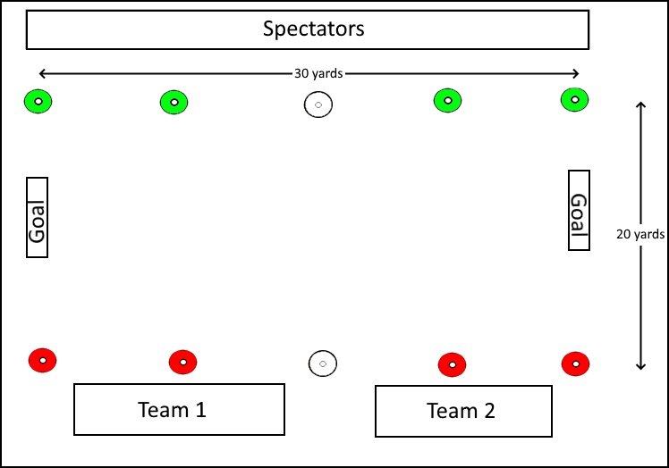

Practice Field Setup
- 20 x 30 yards
- Pugg goals
- Use the white cones to mark the half line on the field.
- Please be attentive to the field space of other teams. Make sure your practice does not encroach another teams. This can become both a distraction and a safety issue. This includes parents who watch the practice.

