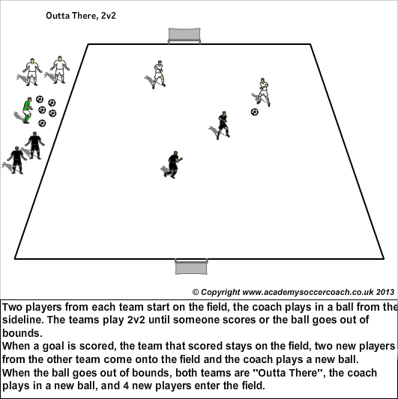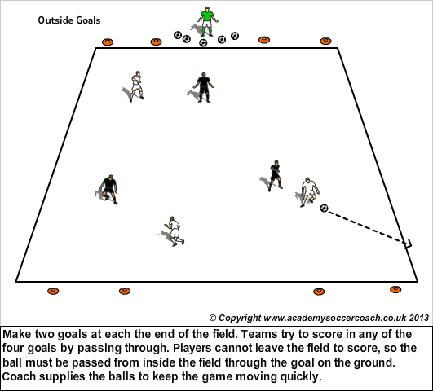
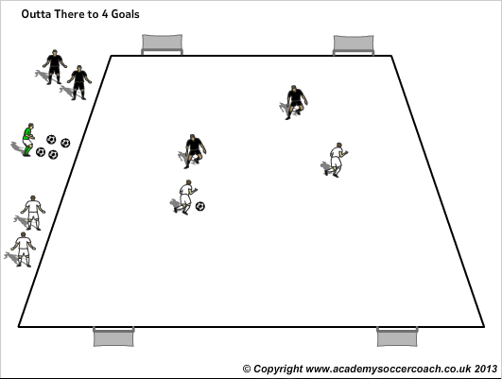
This can be played with more players and gets players to switch the ball to score in the other goal and in to space.
U5/U6 Session1 dribbling
Activity 1: Back to the coach (3x1 minute with 1 minute rest in between)
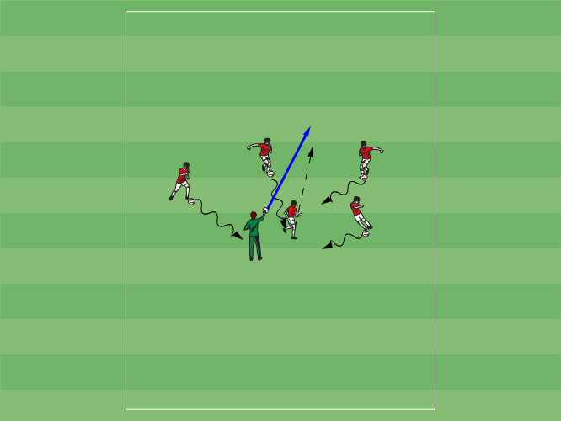
Each player has a ball. Coach stands in the middle of a playing area. One at a time each player hands their ball to the coach. The coach tosses the ball out and then has the players bring the ball using a variety of ways to move the ball. . Example: Run, pick up the ball and skip back to coach, Run pick up the ball and hop back to coach. Progress to having the players dribbling the ball back to the coach.
Coaching points: Head up to find the coach. Being aware of other players when dribbling back to the coach, can you use your laces or pinky toe when running with the ball.
Activity 2: Red Light, Green Light (x4) 10 minutes
All the players start on a designated line with the coach about 15 yards away. With his back to the players the coach yells "green light" and the players try to dribble to the coach. When the coach yells "red light" he waits a moment then turns around, anyone who is not stopped moving has to go back.
Progression: the coach can move to make the game more challenging.

Coaching points: When dribbling, toe down, use laces. Hips forward. Try and keep head up.

Activity 3: Home (10 minutes)
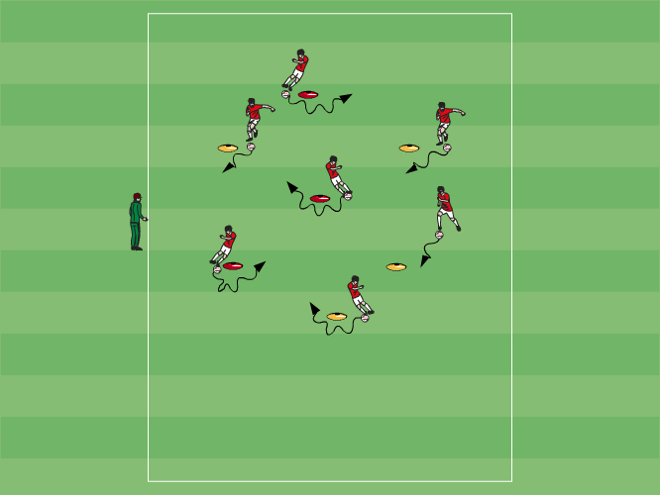
Place different colored cones if available. Each player starts at a cone. Starting cone is called "home". Ask players to move from cone to cone in a variety of ways. At first try the activity without the ball. Consider the following movement actions: A) Run and touch a cone. See how many they can touch before "home" is called. B) Run and hop over a cone with two feet. C) Run and touch a cone with their hand. Then add a ball. Progression: A) Dribble from cone to cone. Don't touch the cones. B) Dribble around a cone and then go to a new one. C) Dribble around a cone and then go to a different colored cone.
Coaching points: Running with the ball using pinky toe or laces. Turning the ball with the inside or outside of the foot.

Game situation: 1v1. Split the field in to 4 sections. Have 5 (depending how many kids) in each section. 1player is the defender/ the others are trying to get to the other side, one at a time. Rotate the defender. You may want to do this without a ball depending on the ability of players.

