MEN’S BASKETBALL TRYOUT INFORMATION

1. Requirements to try out:
- must be eligible per GHSA guidelines (classes passed, credits and residency)

B REQUIRED paperwork: Information can be found on the North Cobb High School Website: Go to www.northcobbathletics.com , scroll down to “athletic registration” and click on “athletics registration instructions”.

Forms must be uploaded by Monday, October 13th. These forms must be uploaded and have “cleared” account status BEFORE tryouts or athlete will not be able to participate. NO CLEAR ATHLETIC ACCOUNT = NO TRYOUTS.

2. Tryout times:

- Try-outs times for Monday (10-20) and Tuesday (10-21) in NC Arena/Main Gym 10th-12th graders 3:45 - 6 pm and 9th graders 6-7:30 pm.
- Participants in fall sports will tryout when their season is complete – see Coach Gorsuch in room 300 for dates and times when your season is over.
- Tryouts are closed sessions for players and coaches only – no parents
- Tryout times/locations may be changed due to volleyball playoffs – changes will be communicated during school announcements.

3. Selection Criteria:

- Basketball skills – offensive, defensive, rebounding, screening, etc..
- Athleticism – size, speed, strength, agility, jumping
- Intangibles including attitude, work ethic, coachability
- Academics
- Behavior/Conduct
- Depth at position relative to year in school

4. Coaching Staff
Head Coach – Terry Gorsuch terry.gorsuch@cobbk12.org
Asst. Coaches– Cody Carden, Byron Taylor
Community Coach – AZ Simmons

5. Player fee for those who make team – approximately $500

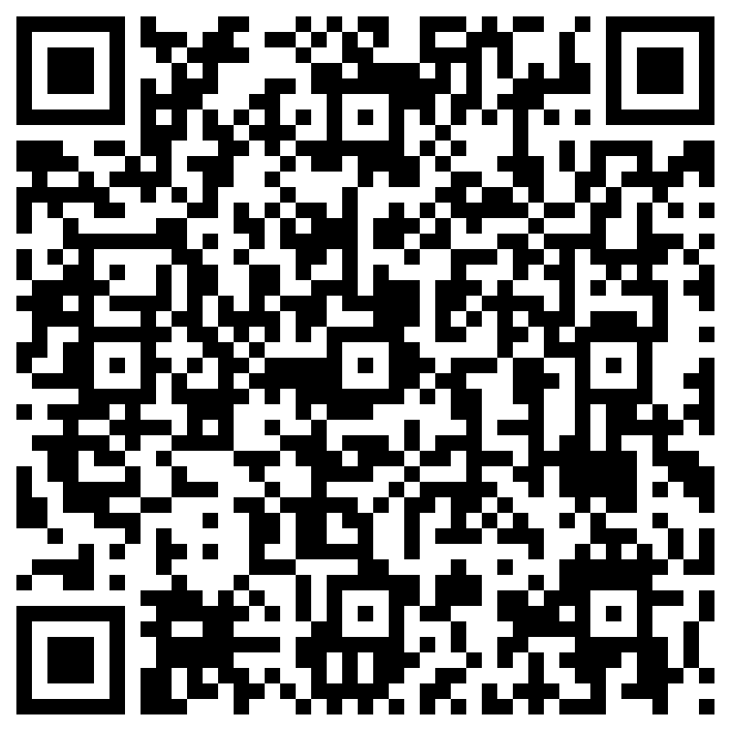
Information form for player to fill out before try-outs

