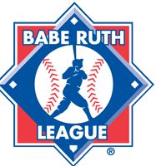
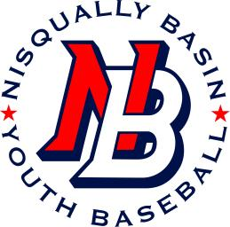
Nisqually Basin Youth Baseball
Representing Yelm and Surrounding Communities
Player Code of Conduct
- I will work hard at all times during practice and in games.

- I will be a role model by setting the example for other players.

- I will not be afraid to ask my coach what I can do to improve.

- I will pay attention to my coaches. I understand they are volunteering their time for me. I will show them respect by looking them in the eye when they are speaking.

- I will show commitment by learning the rules of the game.

- I will show respect for my teammates by cheering for them and helping them as much as possible.

- I will show respect for everyone in the program; the referees, the coaches, and the players. I will not tease or make fun of any player at any time.

- I will encourage fair play and always play by the rules.

- I will never give up and I will always do my best.

- I will remember I represent my entire team and the league on and off the field and I will behave accordingly.

- I will remember that we are here to have fun.

- I will put the needs of the team ahead of my own.

___________________________________________ ____________________
Player Signature Date

___________________________________________
Printed Name

