MAC ATTACK TIME CLOCK
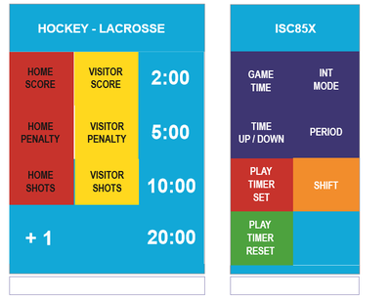
Power button is in back on right side.

Main display board slow to turn off when power is cut.

Make sure the display screen states DOWN. If not, hit the purple Time Up/Down button.
WARM UPS:
Press INT MODE, Enter 2 MINUTES, press enter, enter
FYI: can put in 15 minutes for ZAM time same way

RUN THE CLOCK:
Switch on the bottom right run/ stop after buzzer runs out
Press INT MODE to end and exit screen

SET TIME & SHIFT:
Press GAME TIME, Enter 24 MINUTES, press enter, enter, enter (or put in 0’s then enter)*
Press SHIFT, Enter 2 MINUTES, press enter, enter (or put in 0’s then enter)
FYI: check that ‘time remaining in shift’ is at 0:00. If not, press SHIFT a second time to move cursor down, press 00, enter, 00, enter (may need to press SHIFT 2 consecutive times if the cursor has disappeared)
Press GAME TIME, to return to the main screen

RUN THE CLOCK:
Switch on the bottom right run/ stop after final buzzer runs out

*Championship Games are 2-20 minute halves for Blue & 2-24 minute halves for White and Red

