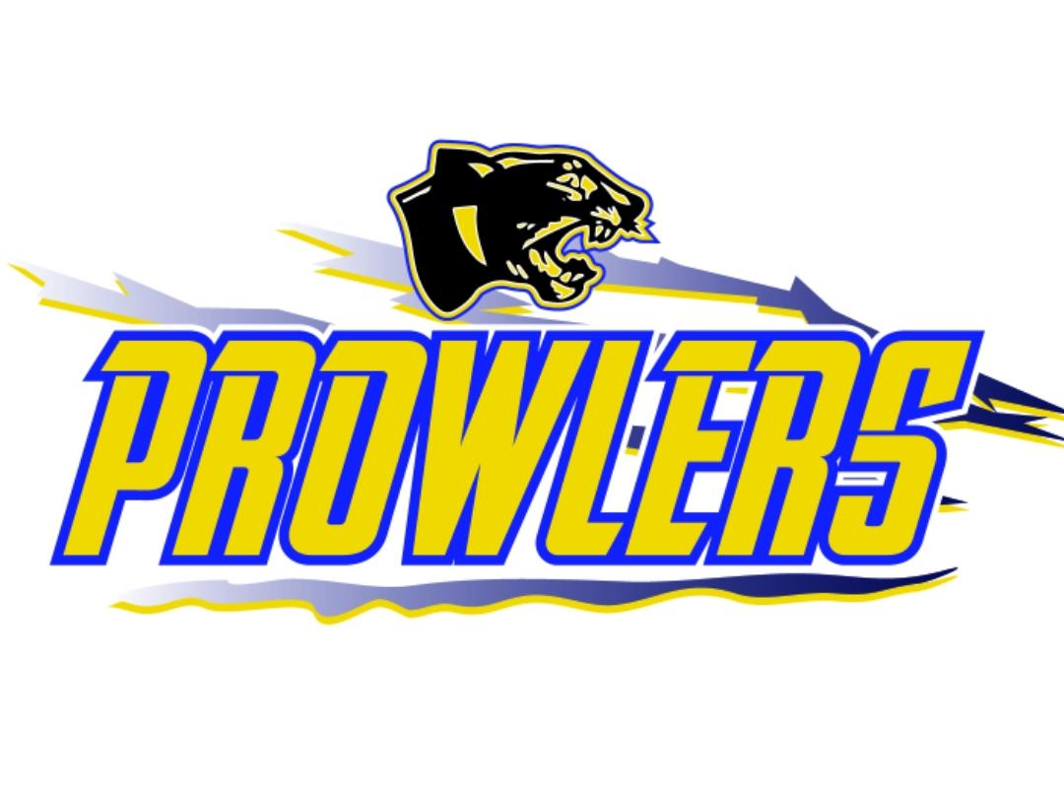
Thief River Falls Amateur Hockey Association
Board Meeting Agenda
The American Legion
Monday September 23rd, 2024
Finance Meeting 5:30 PM
Meeting 6:00 pm

- Call Meeting to Order:

- Review and Approve Agenda: 1st Kate 2nd Danielle

- Requests to Appear:

- Approve Minutes of: 9/09/2024

- Treasurer’s Report/Finance Committee
- Finance Committee report
- Approve checks

- Gaming report.
- Finance Committee report

- Administration
- Committee Reports and Assignments
i.Master Schedule
Games are mostly scheduled
ii. Safe Sport Committee Report
iii. Tournament Committee
iv. Gaming Committee
Gross: $146,150 after paid out $ 20372.48
Lawful purpose $3561.33
Allowable expenses $12,236.19
Golf Course will be shut down for the year in October

v. HOC Committee Report
Coaches: Bantam – Keaton Huot, JR Novak, Cam Olstad
15U – Mike Eickman, Josh Knott, Elizabeth Jahn
12U – Brady Menuier, Jake Johnson, Darrin Torkelson, Nate Dicken
10U – Schnieder, Blair Lund, Aaron Enge
8U – Chris Lawrence, Jared Rierson, Dylan Langevin
PeeWee – Cody Bottem , Corey Poole (A)
Squirt – Travis Collins (A)
Mite –
Level 1 Coordinator – Cody Bottom

vi. Old Arena

vii. Other Committees and Committee Assignments

- Old Business
  - Policies and Procedures
  - Ralph weight room update.
    - Equipment will be delivered mid-november

- New Business
- Dibs Fundraising Starting Date
  - January 1st. – possibly starting early TBD from Travis Collins
    - Earn 10% roughly per event

Approve Coaches:
1st Danielle 2nd Cody *passed

Gambling motion to estimated spend $8500 for the month of September
1st Kate 2nd Jeff *passed

- Adjournment
  - 1st Jeff 2nd Kate

