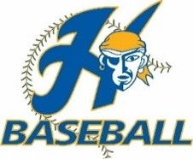
Tball/Farm/Minors/Majors Picture Days
Dates: May 26th, 27th, and 28th
Location: Hastings Vets Park by Playground

May 26th Pictures: T-Ball
- 5:00PM – T-Ball Gold
- 5:15PM – T-ball Royal
- 5:30PM – T-Ball Grey
- 5:45PM – T-Ball Columbia Blue

May 27th Pictures: Farm and Majors
- 4:30PM – Farm Gold
- 4:45PM – Farm Royal
- 5:00PM – Farm Charcoal
- 5:15PM – Farm Vegas Gold
- 5:30PM – Farm Orange
- 5:45PM – Farm Grey
- 6:00PM – Farm Columbia Blue
- 6:15PM – Farm Navy
- 6:30PM – Farm White
- 6:45PM – Majors Royal
- 7:00PM – Majors Gold
- 7:15PM – Majors Columbia Blue
- 7:30PM – Majors Grey

May 28th Pictures: Minors
- 5:00PM – Minors Columbia Blue
- 5:15PM – Minors White
- 5:30PM – Minors Grey
- 5:45PM – Minors Orange
- 6:00PM – Minors Gold
- 6:15PM – Minors Vegas Gold
- 6:30PM – Minors Royal
- 6:45PM – Minors Navy

