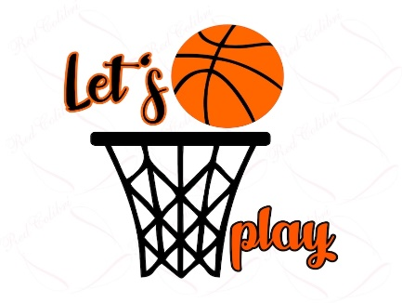
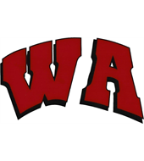

West Allegheny Girls Basketball
Best of the West Tournament
January 21-23, 2022
- 3 Game Guarantee
- Maximum 6 teams per bracket – A & B Brackets if enough interest.
- Only Teams sponsored by local townships or schools will be allowed to enter – NO AAU or All-Star Teams permitted.
- Organizations must complete separate registrations for each team entered in the tournament – please include a roster of all players with the team’s registration.
- One Head Coach, one Assistant Coach & One Bookkeeper per team included with registration
- Minimum 8 players to Register a team - Maximum of 10 players per team
- WA School District Covid Regulations will be released to registered coaches prior to the tournament to adhere to the most current and up to date data available.
Entry fee for all grade levels: $275 per team
Register at https://tourneymachine.com/E100866

Please send checks payable to WAGB Boosters to:
WA Girls Basketball
c/o Amy Rozum – Treasurer
247 Finks Run Rd
McDonald, PA 15057
*Registration Open 12/8/2021-1/12/2022. Payments must be received by 1/14/2022 to secure your team’s spot*

The Best of the West Girls Tournament is an official Qualifier for the 2022 Pennsylvania Middle School Basketball Championship to be held in State College on March 18-20th. Top teams in each division will qualify for the State Championship to battle top teams from towns throughout PA.

