Step 1: Go to: https://www.gwlax.org.com/
Step 2: Sign In: user name and password
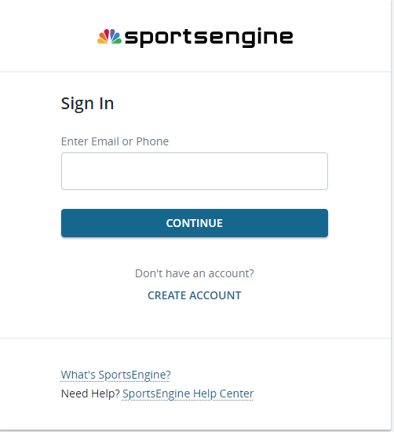

Step 3: Turn on ‘Edit Mode’ by toggling the switch to on using a single mouse click 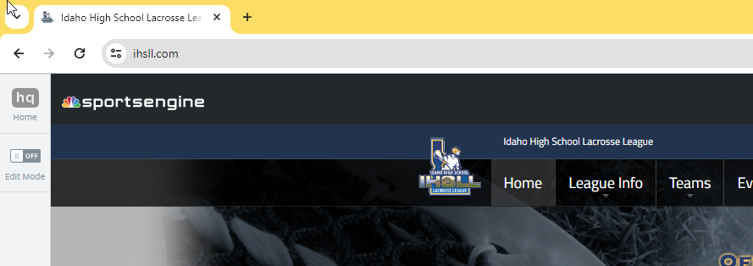
Step 4: On the menu, click on ‘Teams’


Step 5: Select your team using a single mouse click

Step 6: On the menu, click ‘Game Schedule’
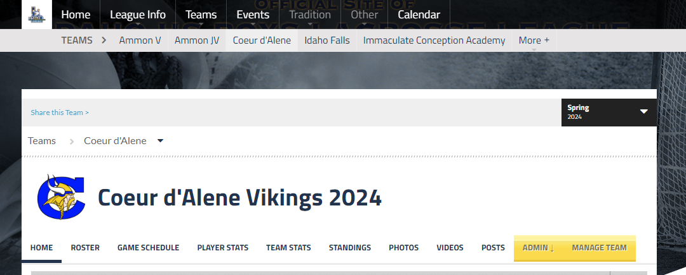

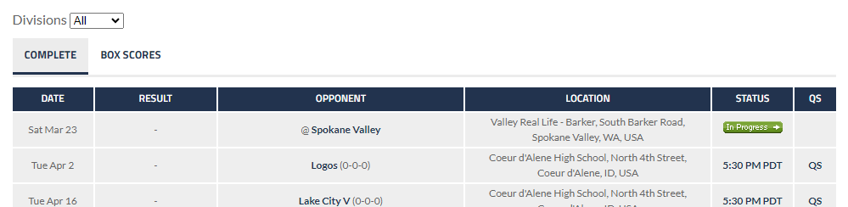
Step 7: Click on the ‘Game Time’ hyperlink in the status column

Step 8: Note: ‘Game Status’ must be set to ‘scheduled’ or ‘in progress’ in order to enter stats
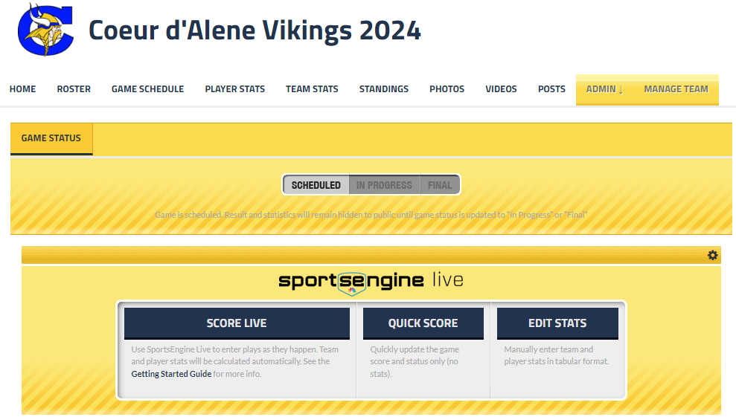

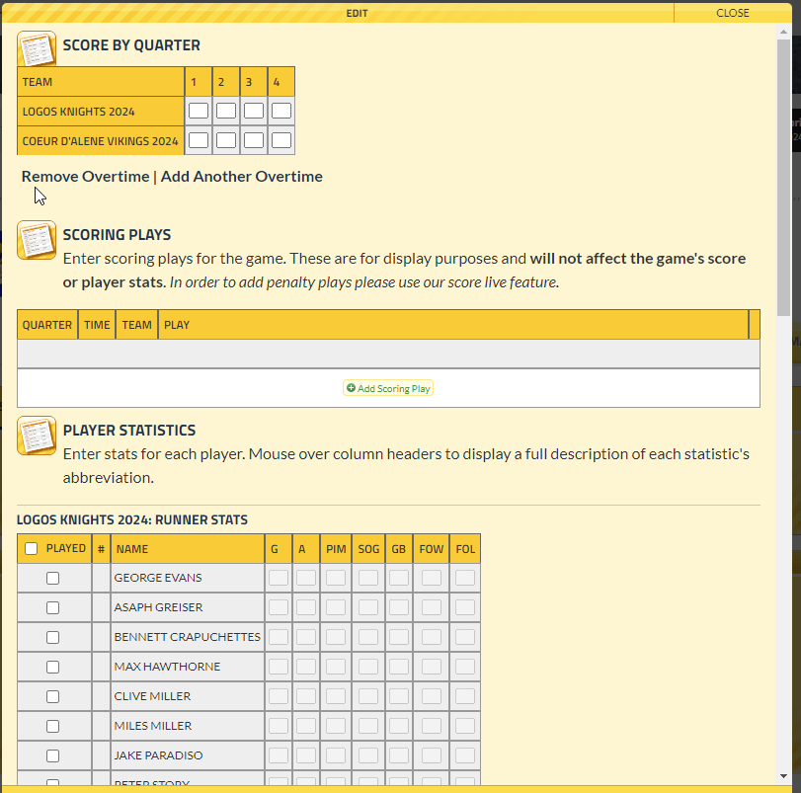
Step 9: Enter stats. Note: Don’t forget to click the ‘Save Stats’ button on bottom right. You can hover over the column headings to see what the abbreviation is for (ie: PIM = Penalty Minutes).

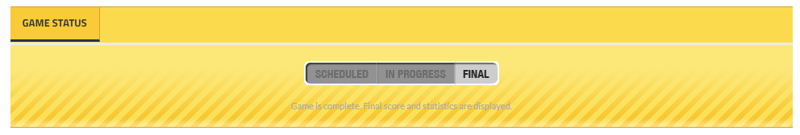
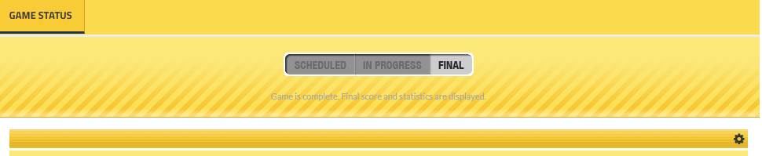
Step 10: If both teams have entered stats, then you set the status to ‘Final” by clicking the button. Note: if the status is marked as Final by the opposing team, that is when you have to change the status to scheduled or in progress in order to enter your team’s stats.

