
Scoresheet Instructions

BEFORE GAME
- HOME: Circle “Home” of left side of page. Write home team name (e.g., “Schenectady Chargers”)
- TIER: Check appropriate game class. SYHA is TIER II
- VISITOR: Circle “Visitor” of right side of page, Write visitor team name
- DATE: Enter the date the game is occurring in MM/DD/YYYY format
- GAME #: Leave blank
- DIVISION : Leave blank
- TIMES: Write game start time
- ARENA: Write rink name “SCRF” or “Union Messa Rink”
- SURFACE: Write name of specific rink if more than rink in a complex
- CURFEW: Leave blank
- PRINTED NAME: Write your name as the official scorer
- ROSTERS
  - Teams should write in player number/name OR provide labels
  - There should be one label on each page (4 total pages)

DURING GAME
- SCORING:
  - The scoring information should be entered in the scoresheet from top to bottom
  - Per = Period goal was scored (e.g., 1, 2, 3, OT)
  - Time = Time the goal was scored (period length minus the time left in the period from scoreboard)
  - Goal = Player number who scored, as provided by referee.
  - Asst = Player number who assisted first, if applicable, and as provided by referee
  - Asst = Player number who assisted second, if applicable, and as provided by referee
  - Ensure the players who have scored or assisted are listed in the player list on scoresheet If they are not listed, then let the referee know immediately
- PENALTIES:
  - The penalty information should be entered in the scoresheet from top to bottom
  - Per = Period penalty was received (e.g., 1, 2, 3, OT)
  - No. = Number of the player receiving penalty, as provided by referee
  - Offense = Reason for the penalty, as provided by the referee
  - Min = Number of minutes for penalty, as provided by the referee
  - Off = Time the player came off the ice (period length minus the time left in the period from scoreboard).
  - Start = Time the player started the penalty (period length minus the time left in the period from scoreboard). Usually same as off time.
  - On = Time the player went back on the ice (period length minus the time left in the period from scoreboard)
- GOALIE SAVES:
  - This is the number of shots not going into the net and is recorded by period
  - Record the total saves for each goaltender in the appropriate period box (e.g., 1,2,3,OT).

AFTER THE GAME

- TIMES: Write game end time
- SCORING BY PERIOD:
  - List the number of goals scored by period.
  - Total the number of goals scored each period to get to the end of game score.
- OFFICIAL SCORE:
  - Print your name legibly at the end of the game.
- REFEREE SIGNATURE
  - Referee must sign the scoresheet at the end of the game
- OFFICIAL(S):
  - All officials must print their names legibly at the end of the game.
- HEAD COACH SIGNATURE
  - Both head coach must sign the scoresheet at the end of the game
- SCORESHEET COPIES
  - Home team is provided top/white copy
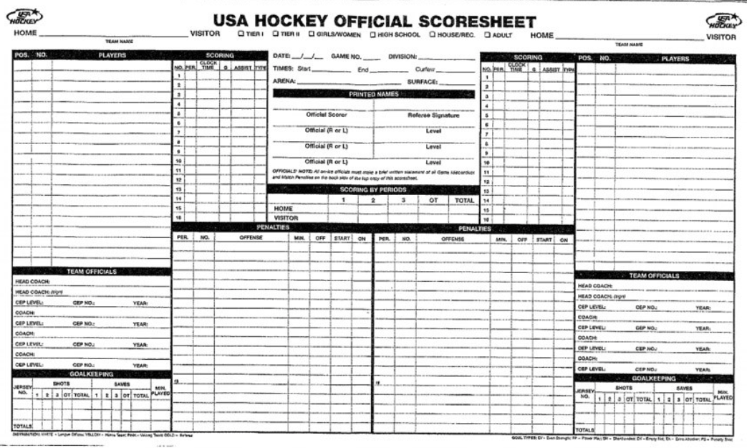
  - Visiting team is provided next copy

