Why is fundraising important?
In order to become a nationally recognized program funds are a top priority to allow athletes to compete at a national level. Funds are needed for program growth. Our program offers items such as camps, clinics, team ,meals, sponsor night, overnight hotel stays and so much more. These are just a few items to develop grass root development from our youth all the way through high school. Providing excellent coaching staff and clinicians throughout the season will bring the wrestling program in Franklin to a nationally recognized program to be proud of. These are just a few of Franklin Wrestling Fundraisers.
- Kroger Reward Program-simply register your Kroger Reward Card to Franklin WC on all gas or grocery purchases support FWC.
FWC Kroger Community Rewards #: AU229
https://www.kroger.com/account/communityrewards
- 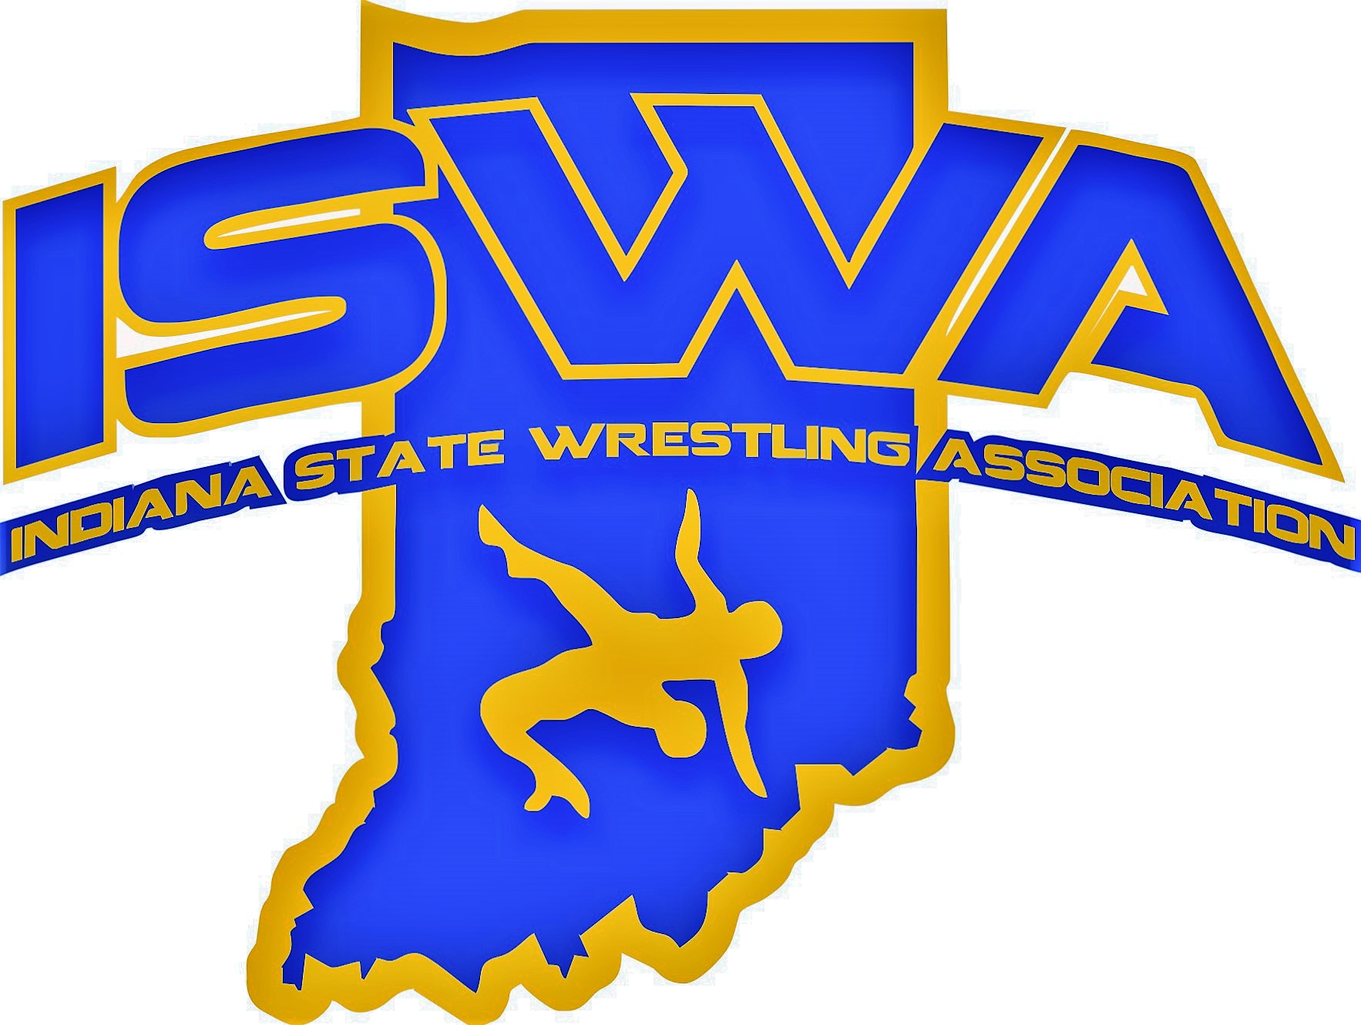
FWC Events: Nov 23 FWC Beginners, Dec 7th FWC Elem Duals, Jan 11th ISWA Elem State Duals, April 18th FWC Freestyle/Greco Tournament.
- Sept 28th FWC Annual Golf Outing @Bluff Creek. This year is our 7th annual event!
- Call-a-thon Fundraiser. 20 phone number challenge.
- May 2026 Euchre Tournament at American Legion Franklin
- Dine to Donate Opportunity. Info will be shared out!
- PICKLE BALL TOURNAMENT….parents wishing to get involved in running a fundraiser please contact Coach Tonte tontej@franklinschools.org

Stay in the know with
-Email (check final forms for current email address.)
-Facebook Group-Parents of Franklin Wrestling
- www.iswa.com/franklinwc
-SportsYou App-Franklin Community High School-Access Code: MK7P-LNHP.

