SLPYHA Board Meeting Agenda
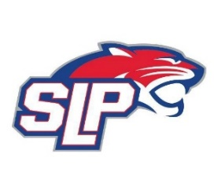
Date: 11/10/20
Zoom
7:00pm

Attendees: Bob Roloff, Scott Lichter, Michelle Rice, Corey Piekarski, Mike Mliner, Kevin Mitties, John Pitzl, Jeremy Flaten

Guests: Cindy Tranby, Anne Heugel

- President Report: Bob Roloff
- Call to order: 7:00pm
- Approve agenda
- Approve minutes from 10/21/20 meeting, motion: Lichter, move: Mliner
- D10 Updates
- Vice President Report: Michelle Rice/Scott Lichter
  - Pictures – Guest, Anne Heugel
  - COVID – Guest, Cindy Tranby
  - Facemasks at FHIT
  - Tournament refunds?
- Treasurer Report/Gambling Report: Mike Mliner
  - Gambling update
- Secretary Report: Corey Piekarski
- Traveling Director Report: Jason Shipman/Chris Mueller
- Girls Traveling Director Report: Kevin Mitties
- Mite Director Report: John Pitzl
  - Summer hockey program
- Coaching Director Report: Jeremy Flaten
- New/ongoing Business:
- Motion to dismiss: 10:01pm, motion: Piekarski, move: Roloff

